Contents

Abstract / Summary 5

Overview 5

Main body of the Text 5

On the Appendices 6

Thesis Style 6

1 Introduction 7

1.1 The Elastic Sheet Model 7

1.2 On the use of Models 8

1.3 Why are gravitation and general relativity of interest for a simulation? 9

1.4 Difficulties of the Theory 9

2 On the Choice of Programming Language 10

3 Initial Development Ideas, using basic Physics 11

3.1 Hooke and Newton 13

4 Initial Mathematics – Numerical Integration Methods 14

4.1 Euler (first order accuracy) 14

4.2 Leapfrog (second order accuracy) 14

4.3 Runge-Kutta 4th-Order Method (RK4) 15

5 Optimal Parameter Choice 16

6 Speeding Things Up – Initial Attempts 16

6.1 Vectorisation and Numpy 16

6.2 Mayavi 17

7 Implementing a Graphical User Interface (GUI) 17

7.1 Tkinter 17

8 Threading in Python 18

8.1 Overview 18

8.2 Motivation 19

8.3 Daemon Threads 19

8.3.1 Code Snippet Example 19

8.4 Sharing Data between Threads 20

8.4.1 Code Snippet Example 20

9 Speeding Things Up 2 21

9.1 Taichi 21

10 Further Physics – The Orbiting Bodies 23

10.1 Orbital Angular Speed of two Orbiting Masses 23

10.2 Power of the Gravitational Waves radiated by a Binary System 23

10.3 Orbital Decay 25

10.4 Reducing Reflections 26

10.5 Viscous Damping (Dashpot Damping) 26

11 Triangle Meshes 28

12 Final Remarks 29

References 30

Appendix A – What can General Relativity Explain? 35

What is General Relativity 35

Gravitational Waves 37

On the difficulty of their detection 37

What are the candidates for producing measurable gravitational waves? 39

Gravitational-Wave Astronomy 40

Appendix B – The Python Language 44

Importing Modules to the Code 44

Different Import types 44

Comments 44

Variable Naming 46

Multiple-word variable names 46

Dynamic Typing 46

Evaluation Order of an Expression 46

Data Collections (Aggregate Data Types) 47

Constructors 50

Operators 50

Assignment Operators 51

Arithmetic Operators 51

Bitwise Operators 51

Comparison Operators 51

Logical Operators 52

Identity Operators 52

Membership Operations 53

Functions 53

Default argument passing 53

The return statement 53

Checking the Code 53

Appendix C – The Tkinter GUI 56

Brief code example and explanation 56

Creation of a Frame (highlighted here, for emphasis, by the yellow box) 56

Colours with Tkinter 57

Colour options 57

Partial Glossary 59

*Dedicated to my mother, 1937 – 2024*

# Abstract / Summary

The goal of this project was the implementation, using the Python programming language, of a simple numerical, computer-based visualisation of gravitational waves emitted by two orbiting bodies. The simulation is for enhancing the conceptual understanding of certain aspects of general relativity, for science teaching and for outreach purposes.

# Overview

This thesis is a documentation of my software implementation, on a laptop PC, of gravitational waves. I wanted to make as much of the details as possible accessible not just to specialists but to those knowing little about either computer science or astrophysics.

My more ambitious aim was that anyone wishing to do so could recreate any or all of the steps leading to the final version of the software, possibly even developing these ideas further for their own teaching or research purposes. Some ideas for stimulating further development of the project are listed in appendix [NOTE: add appendix letter]

# Main body of the Text

My text is constructed as follows:

* I begin by introducing the elastic sheet model, which is often used in pedagogical demonstrations of gravity.
* Then I explain the motivation for this project: Why is it interesting and important to use such an idea to model gravitational waves?
* Section 5 outlines the justification for the use of Python for implementing the project.
* I then explain, in the following section, Section 6 how simple physical ideas can be used for calculating the elements (oscillators) which, in the simulation, represent the undulating surface of the sheet.
* Section 7 highlights some numerical methods to animate the sheet surface. Initial parameter choices are touched upon in Section 8 and ways of improving the rendering speed (performance) are explained in the section that follows, Section 9
* Later on, I disucuss some of the more “computer science”-specific concepts, including the creation of GUIs and threading.
* Finally I show the need for using more powerful machines than simple laptops and show how remote computing can harness the power of GPUs to do a lot of the processing, finally providing the opportunity of smooth and fast rendering.

# On the Appendices

**Appendix A** – What can General Relativity Explain?

Since it is Einstein’s general relativity that predicts the existence of gravitational waves, it may be useful for some readers to know a little about that theory. I describe some of its history and a few observational details, without going into the mathematical formalism, which is (mainly) beyond the scope of this work.

**Appendix B** – The Python Language

This provides the reader with the minimal knowledge of the Python language required for understanding the software implementation.

**Appendix C** – The Tkinter GUI

Here, I provide some details of the graphical user interface (GUI) used in the code, which allows control of the parameters needed for the run. I include a short explanation of the code used to create an object called a slider.

# Thesis Style

This document adheres to the style guide of the *American Psychological Association (APA)*, Seventh Edition (2020)[1]. <https://apastyle.apa.org/products/publication-manual-7th-edition>

# Introduction

Some aspects of gravity (in particular, those of the general theory of relativity) can be represented by various models. A simple and common physical model that is used for gravity is the elastic sheet. This project is a software implementation of a numerical simulation that recreates such a physical model.

## The Elastic Sheet Model[2]

**Figure 1**

*Elastic sheet demonstration of relativistic gravity by* *Dan Burns**, Los Gatos High School, California, United States*

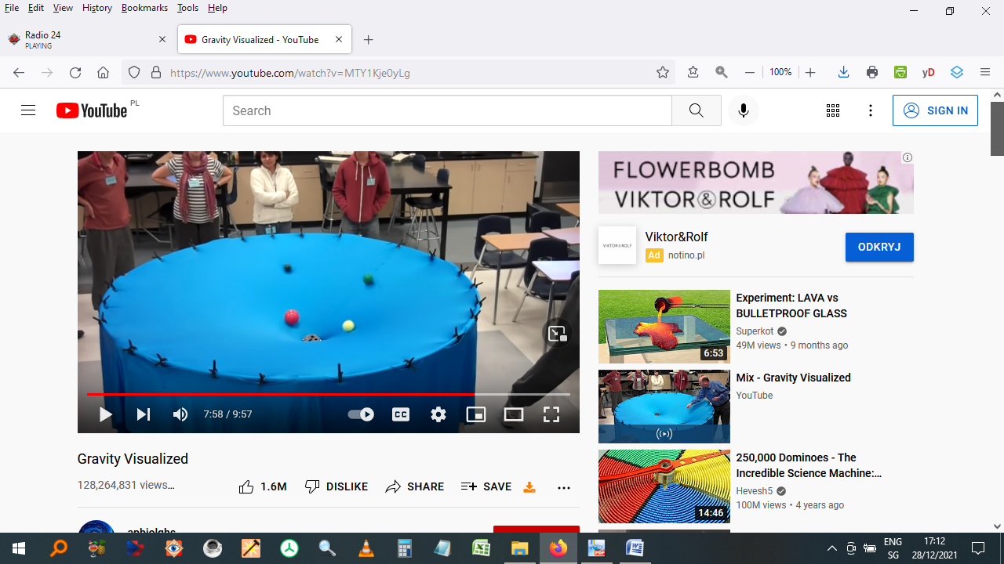

*Note.* Author’s screen shot from the video,

<https://www.youtube.com/watch?v=MTY1Kje0yLg>

In its physical form the elastic sheet model consists of a fabric surface, usually made of rubber or spandex[3], stretched upon a circular or rectangular frame. A metal sphere or an object like a billiard ball or snooker ball is then placed upon the surface and deforms the sheet because of its weight. If additional, smaller, spheres are placed on the surface and given an initial motion in any direction, their paths will become curved due to the distortion of the sheet from the heavier mass or masses. This often results in an (at least partial) “orbit” around the larger sphere. This setup can be used, for example, to approximately demonstrate the gravitational effects of our Sun upon one or more orbiting planets (as the video still of the demonstration, above, shows).

If the model is meant to refer, additionally, to general relativity, the sheet is supposed to represent not space but **spacetime** (three dimensions of space and one of time), the spheres representing (other, much larger!) masses within that spacetime.[4] The greater the mass of spheres used in the model, the greater the local sheet deformation (distortion) around them, hence the greater the masses being represented. The problem is that since the sheet is merely a two-dimensional object embedded in our three-dimensional space, it is limited to representing only two of the four spacetime dimensions!

Some physical elastic sheet models include features such as the gravitational wave production from two centrally orbiting bodies, for example, Mould (2016).

**Figure 2**

*Mechanical simulation of gravitational waves*

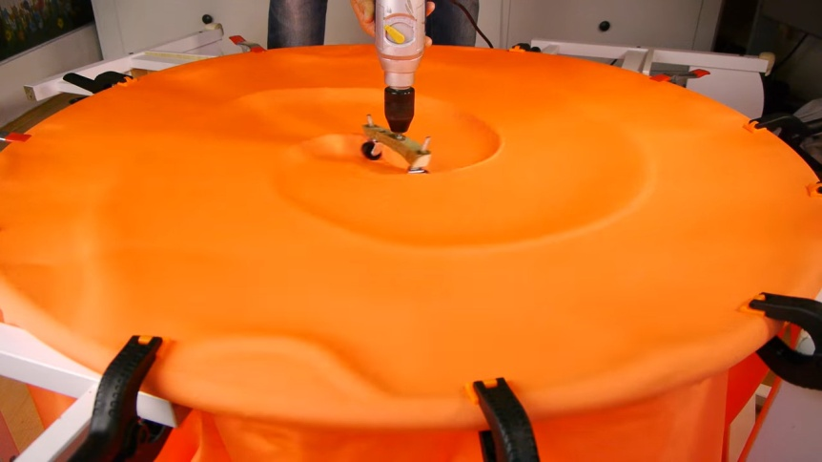

*Note.* Author’s screen shot from the video,

<https://youtu.be/dw7U3BYMs4U>

My work extends the use of real-world materials to replicate gravitational phenomena by people like Mould and others, by doing it all within the software. The additional motivation, apart from not needing to construct anything physical, was that my representation was intended to be

* closer to physical reality in several respects
* able to incorporate some useful parameters, alterable either at the beginning, or during the run itself.

Since my simulation was intended to be a representation of reality, it is worthwhile briefly discussing the use of models as a pedagogical tool in science.

## On the use of Models

In physics, a model (or idealized model) is a simplified version of a physical situation that necessarily omits some characteristics that are present in reality. Writing about models used in science communication, Pössel (2018), elaborates: *A (teaching) model … is a concrete or abstract entity which represents* ***some***[my emphasis] *of the structure … for the purpose of teaching…*

Every idealised model thus represents a **limited set of features** of a physical phenomenon. The skill is in knowing which aspects are “cut out” so that it

* is not a misleading representation
* represents the underlying reality in a useful way.

Models can exist in various forms, in several media. They can be

* physical (including static ones produced by modern 3D printing)
* mathematical
* phenomenological
* visualizations, in the form of a video or computer simulation.

There are several cognitive studies that attempt to reveal how we view models that represent scientific concepts. The age-range of the participants in this research area spans that of school-age children (for example, Baldy, 2007, Postiglione, 2021) to undergraduate students learning general relativity at university (Bandyopadhyay, 2010, Watkins, 2014). One important result of the study by Postiglione, concerning general relativity, was that young people tended to not always understand that **all** masses deform spacetime, not just very large masses such as planets and stars. In principle, we ought to include everyday objects such as houses, cars, people, cats and the coffee cup sitting on the desk at which I’m writing!

Another important point is that a more sophisticated target audience might make the judgement that a particular model’s main features are always more important than those aspects of reality that are under- or unrepresented by it (provided they happen to know, additionally, what those are). But it is important for the educationalist to keep in mind that such an interpretation may not always be valid.

## Why are gravitation and general relativity of interest for a simulation?

*Space-time tells matter how to move; matter tells space-time how to curve*

John Wheeler

The general theory of relativity was published by Albert Einstein in 1915 (Einstein, 1915) and is a refinement of Newton’s law of universal gravitation (Newton, 1687).

It provides a view of space and time that is conceptually and mathematically radically different, however, from the older Newtonian view. Contrary to our intuition, gravity is now regarded less as a force than a **geometric property** of space and time[5] (more accurately, of four-dimensional spacetime). It is the curvature or deformation of spacetime that governs how matter moves within it, as the aphorism by Wheeler quite accurately states.

General relativity is a term with which the public has become more and more familiar with over recent decades. One of the predictions of the theory is that of waves – gravitational waves – moving, at the speed of light, through empty space. The first confirmed observation of such waves was made only relatively recently, however, in 2015. It thus took a century before technology caught up with one of the many predictions contained in the theory and was able to conclusively test it.

## Difficulties of the Theory

*General relativity has a reputation for being very difficult;*

*I think the reason is... that it’s very difficult.*

Leonard Susskind[6]

Unfortunately, in spite of many decades of effort by practitioners and educators in making the theory accessible to a general audience, general relativity’s daunting reputation has hardly diminished since its inception. Susskind has a point!

The obstacles that the theory presents are numerous and (mainly) still valid today:

* General relativity is **conceptually** challenging, featuring abstract concepts like the curvature of spacetime, geodesics and tensors. With the exception of the first term, these are not part of the vocabulary of most people!
* It uses **unfamiliar notation** (something called the Einstein summation convention), which has to be mastered early on.[7]
* It requires advanced undergraduate-level understanding of several branches of mathematics, in particular of **diﬀerential geometry.**
* Finally, once the theory has been grasped – by working through and understanding the derivations leading from a simple curved 2D surface all the way to the so-called **Einstein field equations** and to finally obtaining a useful equation called the **Schwarzschild metric** – there is a new learning curve. This occurs when we want to apply the theory to examine real astrophysical situations. At this “final” stage, one of the additional techniques to learn and apply is called “numerical relativity”, which makes use of modern computing techniques to solve these types of problems.

At first glance these issues would appear insurmountable for science communicators wishing to explain the theory to a broad segment of the public. However, many physical features of general relativity can indeed be presented in a simple and phenomenological (qualitative or semi-quantitative) way. This is done by using models, which brings us full circle to the start of this section.

# On the Choice of Programming Language

Having decided on the **choice of model**, the next stage of planning was to determine **which programming language** (or languages) the simulation would be implemented in. My own area of expertise has been mainframe computer languages used in business.[8] Mainframe programming languages such as COBOL and PL/1 are clearly unsuitable, however, not least because the implementation has to be able to run on modern devices such as laptops. The world of object-oriented programming seemed enticing but presents too steep a learning curve for an MSc project, for someone with no previous knowledge of such methods.

Python was designed in the late 1980s by Guido van Rossum at the CWI (Centrum Wiskunde & Informatica) and developed there by him and others. It was first released to the public in 1991. It is an open-source, high-level[9], object-oriented, programming language. However, as the previous paragraph makes clear, I do not explicitly use any of Python’s Object-Oriented (OO) capabilities.

Additionally, Python is an interpreted language, which means that there is no compilation step: The advantage of this is a reduction of the timescale for each iteration of any edit-test-debug cycle.

It was decided then, provisionally, to implement the software using Python. The initial cost-benefit consideration was:

* Pros:
  + straightforward to learn
  + relatively uncomplicated to code and
  + simple to read (bearing a closer similarity to written English than most alternatives)
* Cons:
  + lack of speed (or the reputation thereof)

At this stage, the question as to whether Python alone would offer sufficient performance was left unanswered. Only experience, rather than calculation, could provide enlightenment.[10] Thus, alternative languages, either for all or part of the implementation, could not yet be ruled out at this exploratory stage.

In this work, I avoid using advanced Python features, in line with my philosophy of pedagogical simplicity. Concepts such as lambda functions [NOTE: check this], generator functions and Object-Oriented Programming (OOP) ideas such as classes, inheritance and polymorphisms are avoided.

Further details can be found in Appendix B.

# Initial Development Ideas, using basic Physics

In secondary schools, one particular physical model sometimes used to visualise waves in physics lessons is called, simply, a “wave machine”. It consists of a series of connected rods, each of which is linked to a spring. The springs are coupled to allow the oscillations of one rod to influence adjacent rods, creating a chain reaction that illustrates wave propagation. Several modules can be linked serially, to produce a longer set of oscillators for the simulation.

**Figure 3**

*A wave machine used at some secondary schools.*

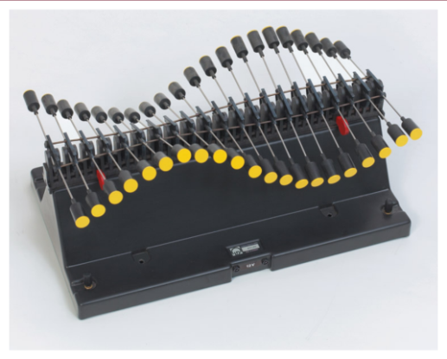

*Note.* Source <https://www.leybold-shop.com/wave-machine-basic-module-1-40120.html>

I wanted to create a software implementation of such a system of coupled oscillators, producing waves in one dimension, as proof of concept. My toy model (Gedankenmodell) consisted of several rings or beads able to move freely and frictionlessly[11], in the *y-*direction (up and down). These were connected by identical springs. The forces, qualitatively, are represented by the yellow arrows. See figure 4.

**Figure 4**

*First concept of coupled oscillators, 1D.*

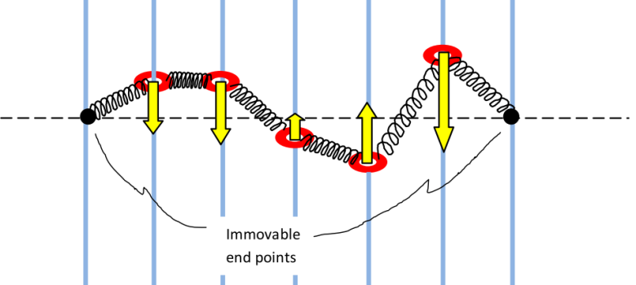

*Note.* Author’s figure

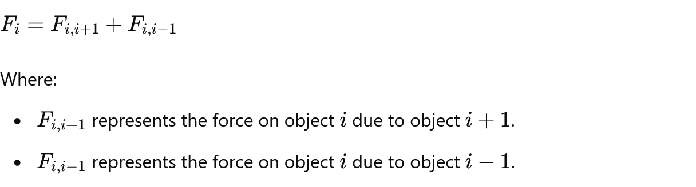A quantitative result is then obtained by calculating the force on each ring/bead, by considering the sum of the two adjacent spring forces via Hooke’s law. The force (along the y axis) is given by

 , **(1)**

where represents the force on bead/ring *i* due to the next one, *i + 1*, and that of the previous one.

Using Hooke’s law then gives:

*D · ∆****l***  i, i+1cos (*θ* i+1) - *∆****l***  i, i+1cos (*θ*i-1) , **(2)**

where:

* *D* is the spring constant,
* *∆****l***  is the length extension or contraction of the spring between *i* and *i+1*, which is assumed to behave symmetrically in terms of the magnitude of force produced, regardless of whether the result of a contraction or expansion,
* *θ*  is the angle between each spring and the vertical (*y*) axis.

Once this model had been coded (in Python) and tested, it was extended from one dimension to two. Conceptually, when “viewed from diagonally above”, a small part of the elementary grid of coupled oscillators would resemble figure 5.

**Figure 5**

*Concept of coupled oscillators, 2D*

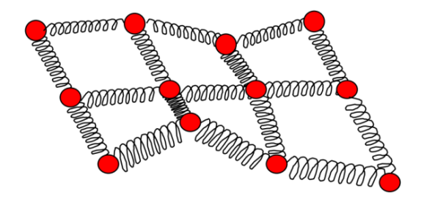

*Note.* Author’s figure

By creating a two-dimensional grid of oscillators, I had now achieved, however rudimentarily, a software representation of the elastic sheet mentioned in section . The difference between the two was that my model was discretised (a mass concentrated at each coordinate point of the grid) rather than being a continuous, smooth entity. However, provided the sheet resolution (in effect, the grid size along each of the two axes) were sufficiently large, the elastic sheet would be well approximated in my representation also.

Since the number of force calculations, according to this discussion, is *Ngrid​2​* we would, for a 200 * 200 grid, obtain 40 000. If we wished to render the movement of waves along our surface at, say, 25 fps (frames per second), we would require one million force calculations each second. This is no challenge for any modern computer (even my laptop machine). The problem now lies with the implementation language. As an interpreted language, Python runs significantly slower than all lower-level, compiled languages (like C/C++), mainly because of the “overhead” of its interpreter.

Calculating forces alone would not be sufficient to produce any meaningful movement of the oscillators making up the sheet surface. The additional information required about them is

* acceleration
* velocity and
* displacement.

## Hooke and Newton[12]

The extension and movement of the oscillators at any particular instant in time can be calculated by using a combination of **Hooke’s law** and **Newton’s second law**. Hooke’s law states that the force due to the deformation (change of extension) of any ideal (perfect) spring is given by

*F = -kΔs,* **(3)**

where *k* is the spring constant*[13]* and *Δs* is the distance the spring is stretched or compressed. The variable *F* here is called the restorative force. Its direction is always opposite to the direction of the spring’s displacement *Δs* (hence the moniker, restorative).

If the sheet is required to be undulating in some fashion in order to produce transverse waves (like water waves), then the freedom of movement for the oscillators could be chosen to be, for example, exclusively in the vertical direction (along the z-axis). The basic equation relating acceleration and displacement for any oscillator would then be given by

*dvz /dt = -kz/m***(4)**

The combination of equations (3) and (4) for our coupled oscillators leads to a first order differential equation (ODE). The vast majority of these kinds of ODEs [NOTE: more specific]cannot be analytically solved (“solved by hand”); their implementation has to be done numerically, on a computer, which is, in effect, the main point of this project. The key idea for the calculations is to perform something called an **iterative temporal discretisation.** [NOTE: add to glossary and link] Unlike in pure mathematics, our computer code cannot truly use infinitesimals, so we have to replace ***dt***with the interval ***Δt****.*

The aim is then to end up with as small a value for this time interval as possible, whilst ensuring that the animation still runs at a visually satisfying speed.

# Initial Mathematics – Numerical Integration Methods

There is a choice of several different numerical methods that can be applied to our problem of coupled oscillators. Each method has its own strengths and weaknesses.

## Euler (first order accuracy)

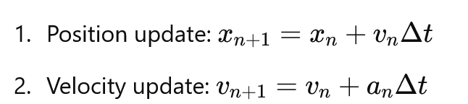It is used to update both position and velocity (or other state variables) simultaneously.

Update of position:

Update of velocity:

**Energy Conservation**: The Euler method generally does not conserve energy well, it can lead to a drift in the total energy of the system over time.

**Momentum Conservation**: It also does not consistently conserve momentum.

The Euler method uses a first-order approximation for both position and velocity updates, which can lead to numerical errors accumulating over time.

**Figure 6**

*Graphical representation of the Euler method*

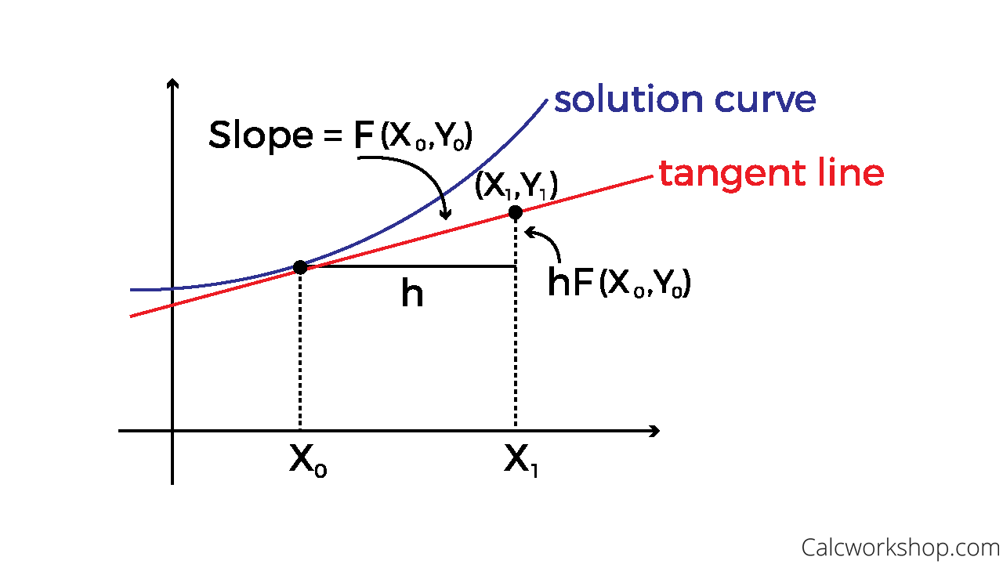

*Note.* Image source:

<https://calcworkshop.com/first-order-differential-equations/eulers-method-table/>

## Leapfrog (second order accuracy)

The method involves calculating the position and velocity at discrete time steps with a "leapfrog" pattern:

**Figure 7**

*Graphical representation of the Leapfrog method*

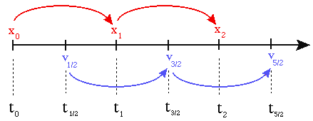

*Note.* Image source:

<http://cvarin.github.io/CSci-Survival-Guide/leapfrog.html>

The steps are

1. Update of position: The position is updated at integer time steps using the (updated) velocity from the previous step.

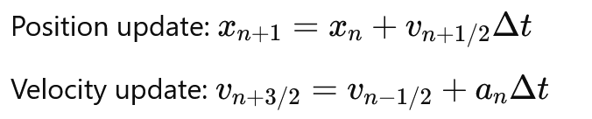

1. Update of velocity: The velocity is updated at half-integer time steps. 

**Energy Conservation**: Leapfrog integration is known for conserving energy better than many other methods. This is because it symmetrically updates positions and velocities, viz.: Leapfrog integration maintains the time-reversal symmetry of the system. This helps in preserving the total energy over longer simulations, reducing the numerical drift in energy that is common in other methods.

**Momentum:** This is also well conserved.

## Runge-Kutta 4th-Order Method (RK4)

This method produces solutions to ordinary differential equations using a fourth-order approximation.

**Figure 8**

*Graphical representation of the RK4 method*

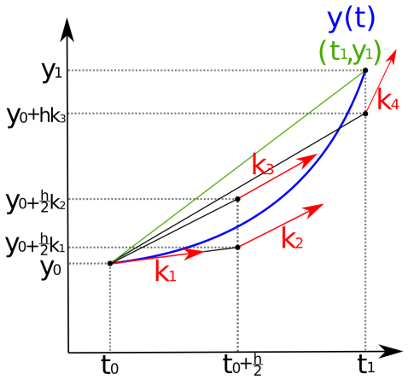

*Note.* Image source:

<https://lowebms.readthedocs.io/en/latest/_images/RK4.png>

It computes four slopes, that are used as intermediate values. Generally, an indexed letter ***k***is used (as referred to previously, in footnote 13):

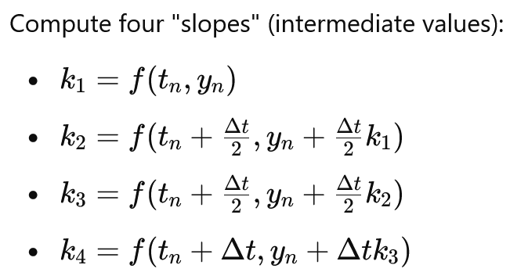

The solution is then calculated using:

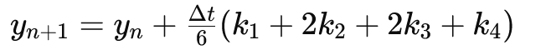

We can see that the computational requirements for the RK4 method are significant: four function evaluations per time step compared to Leapfrog’s two. Accuracy comes at a cost!

**Energy conservation**: RK4 does not inherently conserve energy.

**Momentum conservation:** Not fulfilled either.

# Optimal Parameter Choice

For this project it was important to obtain waves that could be accepted as being sufficiently “wave-like” in appearance. Several parameters needed to be arbitrarily “fine tuned” during the code development for this to be the case. The following parameters were of this type.

* Those required to be minimized:
  + Stepsize (integrative timestep).
* Those required to be maximized:
  + grid resolution size.
  + elastic constant for the coupled oscillators (same value for all).
  + initial elastic extension for the coupled oscillators (same value for all).

Although the point of the user interface (GUI) was to allow the user to change some parameters, because of the above restriction, the option of setting/altering them via the GUI was precluded; instead, they would be hard-coded.

Comparing the integration methods Leapfrog and RK4, it was found empirically that Leapfrog was more unstable (more often prone to growing instabilities – large “spikes” on parts of the grid surface growing without limit) than RK4 for

* large values of the elastic constant, of order 108 and above and/or
* values of the timestep of and above order 10-6.

These empirically-determined values were not universal, however; they only applied to this project.

# Speeding Things Up – Initial Attempts

## Vectorisation and Numpy

Since one of the key strengths of computer software is the ability to repeat tasks in the form of programmed loops, it was here that ongoing optimisation was searched for. A useful technique, for large datasets (data aggregates), is to perform operations on entire arrays instead of working with one element at a time. This means that fixed data types and contiguous (adjacent) memory allocation must be enforced (implicitly, “under the hood”). This technique allows the avoidance of explicit looping and thus enables faster processing. It is known as either **vectorization,** vector computing, or array computing.[14] **NumPy** is the extension module (library) for Python which provides just such functionality.

It was anticipated that the use of NumPy would thus address the performance issues that were already beginning to arise during the development-test cycles. Implementing and running Python with Numpy did help, at least for simple, relatively small arrays. However, it soon became clear that other methods, libraries or interfaces to other (faster) languages would need to be used in the next stage of development.

## Mayavi

Mayavi is an open-source, cross-platform, 3D scientiﬁc data visualization package. It was created in 2001 by P. Ramachandran. Due to the fact that

* its interface can visualise the 3D data described by NumPy arrays[15] and
* since it uses openGL for its rendering[16],

Mayavi, working together with Python, seemed the obvious choice at this stage. However, although the results, visually, looked quite pleasing[17], as the example given by figure 6 shows, frame rates were too low to be useful for a good animation.

**Figure 9**

*Early screenshot using Python with the Mayavi package.*

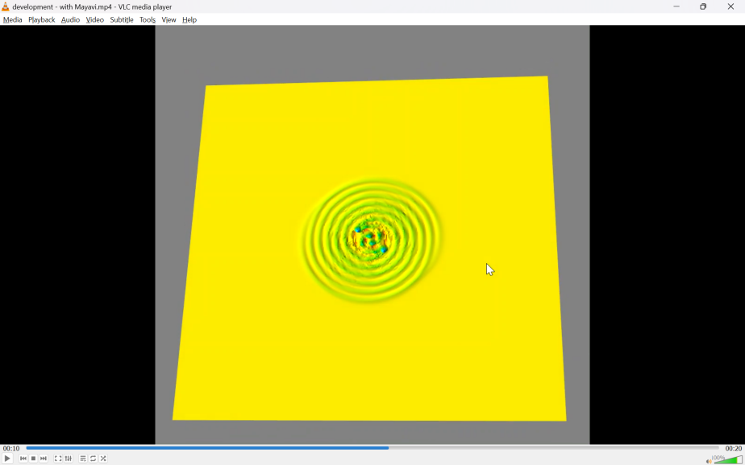

*Note.* Author’s image

# Implementing a Graphical User Interface (GUI)

In order to allow more control of the animation, it was necessary to implement a Graphical User Interface. This would allow some parameters to be set by the user either at the beginning and/or during the run (“on the fly”).

## Tkinter

**Tkinter**[18] is Python’s standard GUI and is probably the simplest way to develop visual elements for Python[19]. I chose it for this reason. Two other noteworthy GUIs for Python are called wxPython, and PyQt; these are not discussed further in this work.

The interface provides a way to create GUI components (often referred to as widgets)[20] such as

* windows,
* sliders,
* buttons,
* labels and
* text boxes.

This project uses all of these.

The name “**Tkinter**” comes from “**Tk interface**“, referring to the Tk GUI toolkit that Tkinter is based upon.

**NOTE: update this section**

The command **root = Tk()**

Tk() is a **class** in Tkinter that represents the main window of the GUI application.

The command root = Tk()initializes a Tkinter window, which serves as the main container for all other widgets (buttons, labels, frames, and so on).

Starting Tkinter

This is done by running the command root.mainloop(). This starts an infinite loop which is used to run the application and act upon user input, as and when it occurs. In computer science, something that indicates a user interacting with a program is called an **event**.

See **Appendix C** for further details, including one code example.

# Threading in Python

## Overview

In computer programs, threads allow the performing of multiple tasks concurrently within a single process, sharing resources such as memory and what are called file handles. Each thread is a separate flow of execution[21].

Multiple threads within a process share the same **data space** with the main thread and can therefore share information or communicate with each other more easily than if they were separate processes. Python threading enables different parts of the program to run concurrently: When we run a Python script, it starts an instance of the Python interpreter that runs our code in the main thread. The main thread is the default thread of a Python process.

A thread has a beginning, an execution sequence, and a conclusion. Three useful commands are

* threading.activeCount()**,** which returns the number of thread objects that are active.
* threading.currentThread()**,** returning the number of thread objects in the caller's thread control.
* threading.enumerate()**,** which gives a list of all thread objects that are currently active.

The Python standard library module, **Threading,** allows the creation and management of threads.

Methods provided are

* run() gives the entry point for a thread.
* start() starts a thread by calling the run method.
* join([time])waits for threads to terminate.
* isAlive()checks whether a thread is still executing.
* getName()returns the name of a thread.
* setName()sets the name of a thread.

## Motivation

The reason that threading had to be explicitly programmed is because the tkinter GUI runs in an infinite loop, once started. However, once the GUI is visible (and parameters have been adjusted by the user, if required), we also need to start at least one other part of our script, dealing with:

* the repeated computing of the oscillator positions in time, and
* the rendering of the resulting surface as an animation on our computer screen.

The GUI remains displayed during the whole animation sequence, because some of its parameters are designed to be modifiable “on the fly” by the user. Sensible choices had to be made about the positions and relative sizes of the GUI root window as well as for a small supplementary display window [NOTE: edit this] (more on that later), especially as all three were designed to be displayed at the same time. An early decision was to set the code to keep both the GUI and the information windows fixed (non-moveable) and non-resizeable.

## Daemon Threads

In Python, **daemon threads** are threads that run in the background and cannot block the program from ending even while they are still running. Any daemon threads will shut down immediately when the program exits. This project does not use them, but I mention this aspect of threading here for completeness.

### Code Snippet Example

|  |  |
| --- | --- |
| Code | Explanation |
| **from threading import (Thread,** | Allows the creation of Thread objects later in the code. |
| **Event,** | Allows synchronization between threads so that one or more threads can wait until they are notified that an event has occurred. |
| **…)** |  |
| **…** |  |
| **simulation_thread = Thread(target=main_simulation_loop)** | Create the thread object called simulation_thread. |
| **simulation_thread.start()** | Once a thread object is created, its activity must be started by calling the thread’s start() method. |
| **…** |  |
| **def main_simulation_loop():** |  |
| **…** | …other lines of code that form part of the definition of the code block. |

## Sharing Data between Threads

An important feature of threads is that they can exchange data, but do not have to do so. Sharing of data between my running threads became a necessity, once the decision had been taken to implement an active, rather than a passive, GUI (i.e. responsive to any permitted user input, at any time during the animation run).

If the same fields of data is to be accessed by more than one thread, it needs to be ensured that a thread **race condition** does not occur**.** When two or more threads access shared data concurrently, the outcome of their execution may be unpredictable. The operating system can swap which thread is running at any time. Any updating of shared data resources is then not guaranteed to work because one thread could be reading a variable exactly at the same time as another is attempting to update it. In fact, the situation is worse than that because even a simple operation (such as x += 1) takes the processor several steps (separate processor instructions) to execute, and a thread could be “swapped out” between the execution of any of these instructions!

Python avoids the race condition by means of something called a **Lock**. The way this works is illustrated in the example code snippet.

### Code Snippet Example

|  |  |  |  |  |
| --- | --- | --- | --- | --- |
| Code | | Explanation | | |
| In the main code, global scope | | | | |
| **from threading import (…,** | We now consider only the parameter Lock in the import statement. | | | |
| **Lock)** | Used to ensure that only one thread accesses a shared resource at a time. This prevents multiple threads from interfering with one another (race condition). | | | |
| **…** |  | | | |
| **shared_data = {** | The data that will be shared between two or more threads. | | | |
| **'lock': Lock(),** | Used to ensure that only one thread accesses a shared resource at a time. This prevents multiple threads from interfering with one another (race conditions). | | | |
| **'running': False**  **}** | We set our default to Boolean false, so that it must be explicitly set to True in the code. | | | |
|  |  | | | |
| In the main loop | | | | |
| **loop_end_time = time.time()** | | | We use the system time to compute the loop run time. | |
| **loop_duration = loop_end_time - loop_start_time** | | |  | |
| **if loop_duration != 0:** | | | Check for divide by zero. | |
| **fps = 1/loop_duration** | | |  | |
| **else:** | | |  | |
| **fps = 1** | | |  | |
| **loop_start_time = loop_end_time** | | | Reset the variable. | |
| **...** | | |  | |
| **with shared_data['lock']:** | | | Only allow current thread access to the shared data. | |
| **shared_data['running'] = True** | | | Check that the data is available. | |
| **shared_data['fps'] = fps** | | | **Assign** the newly calculated variable to the shared data structure. | |
|  | |  | | |
| Function code block | | | | |
| **def update_info_window(root):** | | | | Function definition |
| **if shared_data['running']:** | | | | Only allow current thread access to the shared data. |
| **with shared_data['lock']:** | | | | Check that the data is available. |
| **elapsed_time = time.time() - shared_data['start_time']** | | | | Do the calculation. |
| **fps = shared_data['fps']** | | | | Take the value of the variable, which was updated in another thread, from the shared data. |

# Speeding Things Up 2

## Taichi

This programming language[22] provides a way for Python to execute high-performance numerical and graphical computations. It was created by Yuanming Hu at Tsinghua University in Beijing in 2018. Taichi uses almost the same syntax as Python.

Taichi function blocks are differentiated from those of native Python by two types of decoratorand everything within such code blocks then has a Taichi scope.

@ti.kernel

* Several kernels, unnested, may exist in the code: All kernels are mutually independent of each other and are compiled and executed in the same order as they are first called.
* They are called directly by Python code (i.e. from the Python **scope**) and serve as an entry point for Taichi.
* Kernels must take type-hinted arguments and return type-hinted values.

@ti.func

* Taichi functions are to be called by either kernels or other Taichi functions: nested functions are allowed.
* Functions do not have to take type-hinted arguments and return type-hinted values.

At the beginning of a Python program execution, Taichi performs a so-called just-in-time (JIT) compilation, which translates Taichi code into optimized machine code.

Taichi represents a mesh by two separate arrays, so that the triangle connections are managed independently of the actual vertex positions.

* an **Index Array** (or Connectivity Array). This holds sets of three indices which define sets of triangles
* a **Vertices Array**, holding the coordinates of the vertices in space in the form of a 3D vector.

# Further Physics – The Orbiting Bodies

## Orbital Angular Speed of two Orbiting Masses

We know from Newton’s universal law of gravitation, that the force between two masses *M1* and *M2​* separated by a distance *r* is given by:

*FG = G M1 M2* (1)

*r2*

where *G* is the gravitational constant (Newton’s constant). The centripetal force between them is

*F*C = *M1v12* = *M112 r1* = *M222 r2* (2)

*r1*

The centre of mass is defined as the point where the weighted relative position of the masses balances,

*x* = *∑ (mi  xi)*

*∑ mi*

So *xBARYCENTRE* =*M1x1* + *M2x2* becomes, on moving the pivot point to the centre of *M1*,

*M1* + *M2*

*r1 = _ M2 a_ ,* where *a* is now the distance between the two bodies.

*M1 + M2*

*Using this, M12 r1* becomes:

*M12*  *M2 a__ ,*  which we know from (1) and (2) also equals *GM1M2*

*M1 + M2 r2*

Hence,

*2* =  *GM1M2* (*M1 + M2*) = *G(M1 + M2)* (3)

*r2 M*2a *M1* a*3*

We can, in our animation, now incorporate what I shall henceforth call the „astrophysical omega“ in our information display window. This omega is based upon the scaled-up (from the grid „toy model universe“ to reality) values of the two bodies‘ masses and their physical separation distance. The value of *G* usedin the software, is, of course, the real value of Newton’s constant as determined empirically.

## Power of the Gravitational Waves radiated by a Binary System

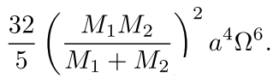

*P* = *G4* *

*c5*

This can also be regarded as the “gravitational luminosity.[23]

## Orbital Decay

The equation for this, without derivation, is

*dr = -* 64 *G3 (m1m2) (m1 + m2)*

*dt* 5 *c5 r3*

where *r* is the separation between the bodies, *t* time, *G* the [gravitational constant](https://en.wikipedia.org/wiki/Gravitational_constant), *c* the [speed of light](https://en.wikipedia.org/wiki/Speed_of_light), and *m1* and *m2* the masses of the bodies.

## 

## Reducing Reflections

In any numerical simulation of waves, the behaviour of the oscillators at and near the grid boundary is problematic. This is because, in general, waves are reflected from all such borders.[24] This behaviour is usually undesirable (unless reflections are intended to be modelled also). In this work, such artifacts are especially undesirable, as it is physically unrealistic to expect reflections of waves (gravitational or otherwise) to be observed in empty space!

One simple technique to reduce border reflections in computer simulations is to code some form of viscous damping.

## Viscous Damping (Dashpot Damping)

In real-life mechanical systems a dashpot is a device that provides damping by creating resistance to motion via a fluid, typically oil, using a piston or cylinder. Since the resistance is proportional to the velocity of the moving component, the damping force increases with the speed of motion. This was the idea for my coded dashpot damping.

We extend the equation of motion like this:

*m d2x* =- *kx* - *c dx*

*dt2 dt*

where, as usual,

*m* is the mass,

*k* is the spring constant,

*x* is the displacement and, now, additionally,

*c* is the damping coefficient (related to the dashpot).

My implementation then imposes a reduction of both the velocities and vertical (height) positions of the oscillators inside the specified boundary regions, with the intensity of damping increasing as each of the four edge boundaries of the grid is approached.

The mathematics for attempting to remove reflections at simulation boundaries is (at least, for me) quite formidable. I provide three references merely to provide a flavour of the mathematics and style of argumentation. Upon researching this topic, I decided that an intuitive, empirical approach was the more straightforward – and, it turns out, still quite effective – way to proceed.

The boundary damping factor found to be optimal in the implementation, assuming a number of damping layers proportional to the grid size (integer division: grid_size//20) turned out to be around 0.05. Clearly, a larger fraction of the grid could always be used for this, but the value chosen (in effect, one-tenth of the grid extent along each of the two axes) does not seem excessive. Utilising too many layers to reduce the reflected waves would negatively impinge upon the model’s overall appearance. (We were not attempting to show an animation of attenuated gravitational waves!).

The same damping factor and depth of layers was used for reducing both the velocity and the position vectors of the oscillators near the borders.

# Triangle Meshes

A mesh of connected triangles, like in **Figure 7**, can be used to approximate any surface. Such a mesh is used to represent and render the virtual elastic displayed by my simulation.

**Figure 7**

*A triangle mesh, representing an arbitrary 2D surface.*

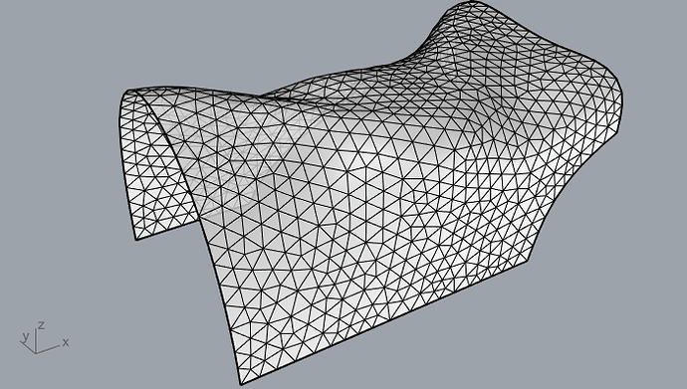

Note. Source <https://discourse.mcneel.com/t/convert-mesh-into-equilateral-triangles/107141/18>

Rendering is done by calculating the vertices of the triangles and then shading the surface obtained.

# Final Remarks

[NOTE: Summary of work,

goals achieved, not achieved,

future enhancements,

overall difficulty or ease of the project.]

# References

* Abbott, B. P., Abbott, R., Abbott, T. D., Abernathy, M.  R., Acernese, F., Ackley, K., Adams, C., Adams, T., Addesso, P., Adhikari, R.  X., Adya, V.  B., Affeldt, C., Agathos, M., Agatsuma, K., Aggarwal, N., Aguiar, O.  D., Aiello, L., Ain, A., Ajith, P., … Zweizig, J. (2016). Binary Black Hole Mergers in the First Advanced LIGO Observing Run. *Physical Review* X, 6(4). <https://doi.org/10.1103/physrevx.6.041015>
* ‌Baldy, E. (2007). A new educational perspective for teaching gravity. *International Journal of Science Education*, *29*(14), 1767–1788. <https://doi.org/10.1080/09500690601083367>
* Bandyopadhyay, A., & Kumar, A. (2010). Probing students’ understanding of some conceptual themes in general relativity. *Physical Review Special Topics - Physics Education Research, 6(2).* <https://doi.org/10.1103/physrevstper.6.020104>
* Bao, H., Hatzor, Y. H., & Huang, X. (2012). A New Viscous Boundary Condition in the Two-Dimensional Discontinuous Deformation Analysis Method for Wave Propagation Problems. *Rock Mechanics and Rock Engineering*. <https://doi.org/10.1007/s00603-012-0245-y>
* Bayes, M., & Price, M. (1763). LII. An essay towards solving a problem in the doctrine of chances. By the late Rev. Mr. Bayes, F. R. S. communicated by Mr. Price, in a letter to John Canton, A. M. F. R. S. *Philosophical transactions of the Royal Society of London*, *53*(0), 370–418. <https://doi.org/10.1098/rstl.1763.0053>
* Bayraktar, S., Gudukbay, U., & Ozguc, B. (2007). Practical and Realistic Animation of Cloth. *CiteSeer X (the Pennsylvania State University)*. <https://doi.org/10.1109/3dtv.2007.4379452>
* Burns, D. (2012). *Gravity Visualized*. Youtube. <https://www.youtube.com/watch?v=MTY1Kje0yLg>
* Carcione, J. M. (1994). Boundary conditions for wave propagation problems. *Finite Elements in Analysis and Design*, *16*(3-4), 317–327. <https://doi.org/10.1016/0168-874x(94)90074-4>
* Cardiff University. *The first detection of Gravitational Waves.* An outreach video produced in and around a swimming pool. <https://youtu.be/Lcxt097G4Ps>
* Coles, P. (2001). Einstein, Eddington and the 1919 eclipse. *In arXiv [astro-ph].* <http://arxiv.org/abs/astro-ph/0102462>
* Dyson, F. W., Eddington, A. S., Davidson, C. (1920). A determination of the deﬂection of light by the Sun’s gravitational ﬁeld, from observations made at the total eclipse of May 29, 1919. Phil. Trans. R. Soc. Lond. A 220, 291 – 333.
* Einstein, A., 1915. Die Feldgleichungen der Gravitation. Sitzungsberichte der Königlich Preußischen Akademie der Wissenschaften zu Berlin, pp. 844-847.
* Ehgquist, B., Majda, A. (1977). Absorbing boundary conditions for the Numerical Solution of Waves, Math. Comput. 31, pp. 629-651. <https://doi.org/10.2307/2005997>
* Farr, B., Schelbert, G., & Trouille, L. (2012). Gravitational wave science in the high school classroom. American Journal of Physics, 80(10), 898–904. <https://doi.org/10.1119/1.4738365>
* Gilmore, G., & Tausch-Pebody, G. (2022). The 1919 eclipse results that verified general relativity and their later detractors: a story re-told. Notes and Records of the Royal Society of London, 76(1), 155–180. <https://doi.org/10.1098/rsnr.2020.0040>
* *Graphical User Interfaces with Tk* *— Python 3.7.4 documentation.* (2019). Python.org. <https://docs.python.org/3/library/tk.html>
* Hamilton, A. J. S., & Lisle, J. P. (2008). The river model of black holes. *American Journal of Physics*, *76*(6), 519–532. <https://doi.org/10.1119/1.2830526>
* Heinold, B.(2012). *A practical introduction to python programming*. Brianheinold.net. <https://www.brianheinold.net/python/python_book.html>

* Hilborn, R. C. (2018). Gravitational waves from orbiting binaries without general relativity. *American Journal of Physics, 86(3),* 186–197. <https://doi.org/10.1119/1.5020984>
* Hilborn, R., *BinaryInSpiral using Python GlowScript IDE*. (2017). Glowscript.Org. <https://www.glowscript.org/#/user/rhilborn/folder/Public/program/BinaryInSpiral>
* Hawking, S. W. (1988). *A brief history of time : from the big bang to black holes*. Toronto : Bantam Books.
* Hubble, E. (1929). A relation between distance and radial velocity among extra-galactic nebulae. *Proceedings of the National Academy of Sciences of the United States of America, 15(3)*, 168–173.
* Kersting, M., & Steier, R. (2018). Understanding curved spacetime: The role of the rubber sheet analogy in learning general relativity. *Science & Education, 27*(7–8), 593–623. <https://doi.org/10.1007/s11191-018-9997-4>
* Klein, B (2021). *Intro to Python tutorial.* Python-Course.Eu. <https://python-course.eu/python-tutorial/>
* *Demonstration of Gravitational Waves on a Spandex Universe - LIGO - caltech*. (2016). Youtube. <https://www.youtube.com/watch?v=YfSyhcFu_MM>
* Klein, B. (2022.) *Creating NumPy arrays*. Python-Course.Eu. <https://python-course.eu/numerical-programming/creating-numpy-arrays.php>
* *NumPy: the absolute basics for beginners — NumPy v1.23 Manual*. (n.d.). Numpy.org. Retrieved July 29, 2022, from <https://numpy.org/doc/stable/user/absolute_beginners.html>‌
* Kraus, U., & Zahn, C. (2021). *Relativity Visualized.* <https://www.spacetimetravel.org>
* McDonald, K. T. (2004). *What is the stiffness of spacetime?*

<https://arxiv.org/abs/gr-qc/0407036>

* Middleton, C. A., & Langston, M. (2014). Circular orbits on a warped spandex fabric. American Journal of Physics, 82(4), 287–294. <https://doi.org/10.1119/1.4848635>
* Mould, Steve. Visualising gravitational waves. (2016). YouTube. <https://youtu.be/dw7U3BYMs4U>
* Newton, I. (1999). *The Principia: mathematical principles of natural philosophy*. (Cohen, I. B., Whitman, A. M., & Budenz, J. Berkeley, Trans.) University of California Press. (Original work published 1687)
* The NumPy community. *NumPy v1.21 Manual*. (2021). Numpy.Org. <https://numpy.org/doc/stable/index.html>
* O’Raifeartaigh, C., & Mitton, S. (2018). Interrogating the legend of Einstein’s “biggest blunder.” *Physics in Perspective*, *20*(4), 318–341. <https://doi.org/10.1007/s00016-018-0228-9>
* The pip developers. (n.d.). *pip documentation v21.3.1.* Pypa.Io. <https://pip.pypa.io/en/stable/>
* *PEP 8 – style guide for python code*. (2013). Python.org. <https://peps.python.org/pep-0008/>
* Postiglione, A., & De Angelis, I. (2021). Students’ understanding of gravity using the rubber sheet analogy: an Italian experience. Physics Education, 56(2), 025020. <https://doi.org/10.48550/arXiv.2102.04156>
* Pössel, M. (2018). Relatively complicated? Using models to teach general relativity at different levels. In arXiv [gr-qc]. <http://arxiv.org/abs/1812.11589>
* Python Software Foundation (2021). 3.10.1 Documentation. Python.Org. <https://docs.python.org/3/>
* Ramachandran, P., Varoquaux, G. (2011). Mayavi: 3D visualization of scientific data. Computing in Science and Engineering, Institute of Electrical and Electronics Engineers, 2011, 13 (2), pp.40-51. <https://dl.acm.org/doi/10.1109/MCSE.2011.35>
* Real Python. (2021). *What is Pip? A guide for new pythonistas.* Real Python. <https://realpython.com/what-is-pip/>
* Riles, K. (2011). *Building Interferometer Exhibits.* LIGO Document G1100384-v1. <https://dcc.ligo.org/LIGO-G1100384/public>
* Rindler, W. (1994): “General relativity before special relativity: An unconventional overview of relativity theory.” In: American Journal of Physics 62, pp. 887–893. <https://doi.org/10.1119/1.17734>
* Saulson, P. R. (1997). If light waves are stretched by gravitational waves, how can we use light as a ruler to detect gravitational waves? American Journal of Physics, 65(6), 501–505. <https://doi.org/10.1119/1.18578>
* Schutz, B. F. (2009). A First Course in General Relativity (2nd ed.). Cambridge University Press.
* Van Rossum, G., & Python Development Team. (2018). *Python Tutorial: Release 3.6.4*. 12th Media Services. Also available on <https://www.w3schools.com/python/default.asp>
* Watkins, T. (2014). Gravity & Einstein: Assessing the Rubber Sheet Analogy in Undergraduate Conceptual Physics. Boise State University Theses and Dissertations. <https://scholarworks.boisestate.edu/td/862/>

# Appendix A – What can General Relativity Explain?

In this section, I provide an outline of general relativity and an overview of some of the observations in astronomy and cosmology for which the theory provides satisfying explanations. The experimental verification of gravitational waves in 2015 has now led to a field called gravitational wave astronomy, providing yet another “window of information” about our cosmos.

## What is General Relativity

General relativity describes how mass concentrations distort the so-called spacetime (our three dimensions of space plus the single dimension of time) around them - and how this distortion affects other objects in their neighbourhood.

Because the scales involved are so immense compared to the scales of our daily experience here on Earth, the theory can explain many large-scale astronomical observations. Within our Solar System an example is the deflection of starlight passing close to our Sun (first confirmed by observations of a solar eclipse in 1919 at made at Sobral, Brazil, and Principe, West Africa)[25] and an effect known as gravitational lensing by (and of) galaxies and groups of galaxies.

**Figure A3**

*So-called Einstein ring created by gravitational lens LRG 3-757*

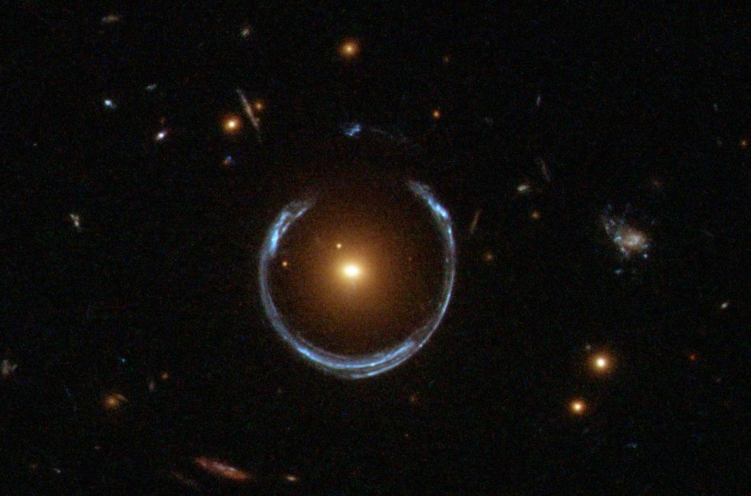

*Note.* Source: <https://apod.nasa.gov/apod/ap111221.html>

Other phenomena that can be explained include the precession of the elliptic orbital shape of the planet Mercury around our Sun and (some of!) the physics of black holes (where a massive star is collapsing “forever” inward and no longer allows anything, not even light, to escape from it).

**Figure A4**

*Cartoon depiction of the precession of the orbit of the planet Mercury around the Sun*

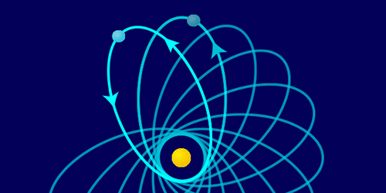

*Note.* Not to scale; distances and angles highly exaggerated.

On the largest scales of all – cosmological scales - general relativity predicts the expansion of the Universe itself! This was not the prevailing view when Einstein published his paper in 1915, as there was no observational evidence to support it at the time. Furthermore, the “static” model would have been favoured by scientists on the additional grounds of simplicity and elegance, compared to any dynamical alternative. This thinking led Einstein, in 1917, to insert a term into his theory called the **cosmological constant**, to allow for just such a static Universe. When, just a few years later, it was observationally confirmed by Edwin Hubble (1929) that the Universe is expanding after all[26], Einstein called the addition of this constant his “biggest blunder”. It appears that this story is not apocryphal but likely to be true (O’Raifeartaigh et al. 2018); one can easily imagine the great physicist’s frustration upon realising that he had missed the opportunity of using the power of his own theory to **correctly predict** an as yet unconfirmed feature of the cosmos!

Since the invention of the telescope in the Netherlands, probably in 1608, and Galileo’s famous use of his own improved versions (primitive, even by today’s standards of many children’s telescopes!) in Italy over the following years, astronomers have been able to more and more effectively make use of the information contained in the electromagnetic radiation emitted by sources in the sky. Indeed, the twentieth century saw the construction, for the first time, of telescopes which could produce images using wavelengths other than the visible part of the spectrum, beginning with radio waves in the 1930s and eventually using the infrared, ultraviolet, X-ray and gamma ray regions. However, since the Earth’s atmosphere prevents nearly all wavelengths shorter than visible light arriving at its surface, observations in these wavebands cannot be made from ground-based telescopes but only from space. For these observations the equipment is placed aboard rockets or on Earth-orbiting satellites.

A well-known example of an astronomical object imaged at different wavelengths is the Crab nebula, the remains of a supernova explosion in our Galaxy recorded by Chinese astronomers in 1054.[27] It can no longer be seen with the naked eye, as its apparent brightness in the sky is around nine times too faint for this, but it can be seen as a small faint patch of light using good binoculars.[28] Each of the four images in the figure below contains different information about the nebula. Since humans cannot, in principle, perceive colours beyond the boundaries of wavelengths visible to our eyes, non-optical images in astronomy often employ “false colours”, to represent signal intensity (and to look aesthetically pleasing).

**Figure A5**

*The Crab nebula in different energy regimes (wavelengths)*

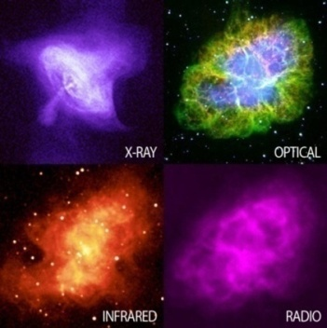

*Note.* Source <https://ecuip.lib.uchicago.edu/multiwavelength-astronomy/x-ray/impact/07.html>

## Gravitational Waves

All masses have a constant gravitational field in the region around them. According to general relativity, however, masses that are accelerating produce something new – the emission of gravitational waves.[29] Accelerated masses produce these waves in a similar way that **accelerating charges** produce **electromagnetic** waves. For example, electrons rapidly oscillating along the length of an antenna emit electromagnetic radiation – photons – with wavelengths in the radio band of the spectrum; this is nothing other than a radio transmitter. Both types of energy can travel through the vacuum of empty space. They do so at the speed of light (3,00**·**108 m/s).

As it turns out, general relativity is not the only theory of gravity that predicts gravitational waves; any relativistic theory of gravity will predict them.[30]

### On the difficulty of their detection

There are several reasons why gravitational waves (as opposed to gravity itself) are extremely difficult to detect (let alone, measure):

* Their interaction with matter is very weak. The gravitational waves emitted by the movement of everyday objects on the Earth (people, cars, planes) are far too small to be measurable. Indeed, the extreme weakness of gravitational waves makes detection diﬃcult even for sources that are large astronomical objects. The amount of energy emitted in this form by objects is extremely small. For example, the power of gravitational waves emitted by a pair of masses *m1* and *m2,* orbiting around their common centre of gravity (barycentre) in circular paths of radius *r* is given (here without derivation) by the following equation:

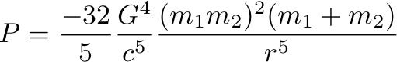

Taking numerical values of Newton’s constant *G* and the speed of light *c* to three significant figures, we see that

*G*4 = (6.67·10-11)4 = 2.02·10-41 and

*c*5 = 2.43·1042.

Combining these gives us an order of magnitude of **10-83** for the proportionality. In order for any significant power to be produced by the emitted waves, the equation tells us that we need truly enormous masses, together with a relatively small orbital radius, in order to “compensate” for this extremely small parameter.

* What is measurable by gravitational wave detectors is the “distortion” of spacetime itself, but it requires large energies in the sources to do this. The “stiﬀness of spacetime”, expressed as the Young’s modulus, can be determined, classically, using the equation

*F* = *Y Δ****l***

*A* ***l***

This gives us the dimensions of the Young’s modulus,

*[Y]* = *F*

*A*

By again using *G* and *c,* but this time using dimensional analysis rather than taking their numerical values, and additionally incorporating frequency, *f*, we obtain

*Y* = *F* = N_= MLT-2 = ML-1T-2 = (LT-1)2 **·** T-2 = *c2* **·** *f 2*

*A* m2 L2 M-1L3T-2 *G*

If we make the assumption that the Young’s modulus is frequency-dependent, we can write

*YSPACETIME* ~  *c2f 2* = 4.5**·**1027 *f 2* .

*G*

For a gravitational wave of frequency 100 Hz we obtain *YSPACETIME* ~ 1020 *YSTEEL* ( ~ 1031 Pa).

It therefore takes vast energies to distort spacetime!

* Third, as for all waves, their flux (power over area) is inversely proportional to the square of the distance to the wave source (*r****-2*** ). Since the energy of a wave is proportional to its amplitude squared, *E* ∝ *A2*, the measured amplitude of the waves will go as 1/*r* .Thus, as expected, the farther out the event creating the waves, the smaller the observed effect seen here on Earth.

Bearing in mind the above three points, we see that it would require events of great violence to produce measurable signals in the best (most sensitive) detectors presently here on Earth. Any system producing the gravitational waves would have to be

* very massive (by everyday Earthly standards!): at least the mass of a Sun-sized star,

*m* ~ 1030 kg, and

* accelerating strongly in some non-symmetrical fashion.

Events of this kind only occur in places far beyond our Solar system (our local region is “boringly average”, luckily for life on Earth).

### What are the candidates for producing measurable gravitational waves?

#### Supernovae

The supernova explosion of a star, if perfectly symmetrical, would not produce gravitational waves, in spite of the violence of the event; but any detection of a gravitational wave associated with one might provide interesting information about the asymmetry of such an explosion. This information could then be “fed into” the supernova models we currently have.[31] A particular problem of supernova modelling is that of “producing the bang” in the first place.

#### Two orbiting bodies

Two stars orbiting one another (since all bodies in an orbit are being accelerated[32]) would also fulfill the above two requirements, at least in principle. Furthermore, the closer the objects to one another, the greater the gravitational radiation produced. Very dense bodies would allow closer proximity without touching, than less dense objects, so a high density is another desirable criterion. The densest objects in the Universe are believed to be neutron stars (or, denser still, black holes, provided these are not of the supermassive variety). Thus the most likely detectable sources of gravitational waves would be two closely orbiting black holes (or a black hole with a neutron star companion). These are indeed what has been observed since the experimental confirmation of gravitational waves in 2015.

In many cases one would expect to see a merger of the two bodies not long after first observing the gravitational waves emitted by such a system. This is because our observations **selectively favour** those events that are already the most dramatic; and we know that the gravitational wave radiation produced by two orbiting bodies are at a maximum when those bodies are spiralling inward and are closest to one another, just prior to their collision and merger.

The reason for a spiral orbit is that the combined kinetic and gravitational potential energy of the binary is constantly being converted into gravitational wave energy which is radiated outwards. This constant loss of energy means constantly shrinking orbits.

We can verify the claim of shrinking orbits by using simple classical (Newtonian) physics, together with the (not very realistic) assumption that the orbits are circular.

The force on body A due to B is given by Newton’s law of universal gravitation,

*FA* = *GmAmB* , (A.1)

*r 2*

where *G* is Newton’sconstant and *r* is the distance between the two masses.

Newton’s second law of motion, *F = ma,* then gives us

*FA* = *GmAmB* = *mAvA2* (A.2)

*r 2*   *rA*

Considering the kinetic energy of each body, we have

*½ mAvA2*  = *rA ½ mAvA2*  = *rA ½ GmAmB*, using (A.2).

*rA  r 2*

Similarly,

*½ mBvB2*  = *rB* *½ GmAmB*

*r 2*

Thus for the sum of the kinetic energy of both bodies, we have

*½ mAvA2*  + *½ mBvB2*  = (*rA* + *rB*)*½ GmAmB*

*r 2*

*½ mAvA2*  + *½ mBvB2*  = *GmAmB* (A.3)

*2r*

The total mechanical energy for the system is given by this kinetic energy plus the **negative** gravitational potential energy:

*E = ½ mAvA2*  + *½ mBvB2*  - G*mAmB*

*r*

which, upon using (3) for the kinetic energy, becomes:

*E = GmAmB* - G *mAmB*

*2r2*  *r*

*E* = - G *mAmB* (A.4)

*2r*

[NOTE: Equations need modification, explanation.]

The radiation of gravitational energy of the binary implies a decrease in the energy of the radiating bodies. A decrease on the right hand side of (A.4) therefore means that the term becomes **more negative**. Thus *r* must be getting smaller, which in turn means that the distance between the two masses must decrease over time. This corresponds with our physical intuition.

## Gravitational-Wave Astronomy

The first gravitational wave detection was an indirect one, via the **electromagnetic** emission, rather than any gravitational emission, of the source. The Hulse-Taylor binary neutron star system consists of two neutron stars, one of which is rotating on its axis 17 times per second and emitting regular pulses of radio waves at that frequency (rather like the sweeping light beam emitted by a lighthouse).

**Figure A6**

*The Hulse/Taylor neutron star binary system. One body is a pulsar, a neutron star that sweeps out a strong radio beam toward the Earth as it rotates. As they orbit one another, both bodies emit gravitational waves, causing a gradual shrinking of their orbit.*

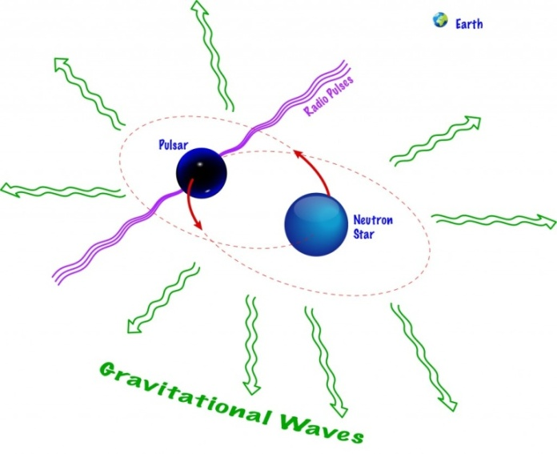

*Note.* Image: Shane L. Larson

The pulsed radio beams are, **by chance**, lined up with Earth and their period is known to be changing in a periodic way. From these observations it can be calculated that the separation between the two neutron stars is slowly decreasing; a shrinking orbit. This can only be explained by the binary continually losing energy in the form of gravitational waves (no other mechanism is known, friction/drag is nonexistent), which transport the energy out of the system. Incidentally, the waves carry not only energy but **information** about their source, such as the mass and spin of the objects, which is of importance.

The ﬁrst **direct** detection of a gravitational wave took place in the autumn of 2015 when the two LIGO ground-based detectors (at Hanford, Washington and Livingston, Louisiana, United States) measured the signal of two coalescing (colliding) black holes (Abbott et al. 2016). The signal was named **GW**150914 – from 'Gravitational Wave' and the date of observation (in the format YYMMDD).

The data analysis for gravitational wave detection is complicated. Part of the problem is that of other, unwanted, terrestrial signals of comparable levels, such as seismic vibrations and road traffic. Some of the several techniques used are known as matched filtering, together with Bayesian inference (Bayes, 1764).

**Figure A7**

*Signals of the first confirmed discovery of a gravitational wave (autumn 2015) observed by the LIGO detectors at Hanford and Livingston, United States.*

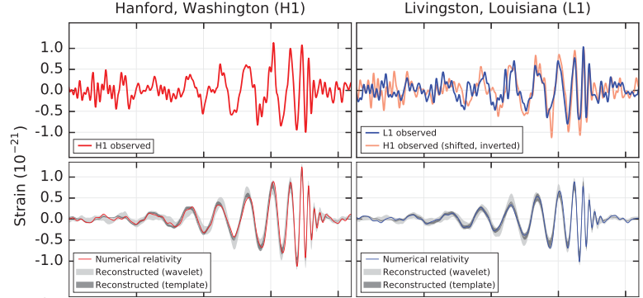

*Note.* Top row: observations at the two sites; bottom row: a simulation for a system with the parameters of GW150914 using numerical relativity. GW150914 arrived first at Livingston and 6.9 ms later at Hanford.

The principle of gravitational wave detectors is that of the **Michelson interferometer**, which uses the interference properties of light.

**Figure A8**

*Schematic of a Michelson interferometer*

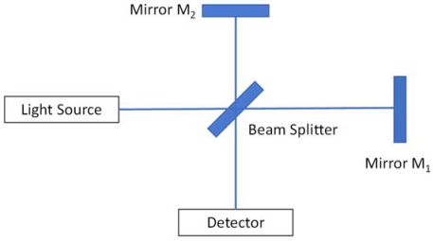

*Note.* Image and text modified from Hilborn (2018).

Light from a source (usually a laser) hits a so-called beam splitter (for example, a half-silvered mirror). Part of the light is reflected from the beam splitter (here, upward) and is later reflected by mirror M2. The other part of the beam goes through the beam splitter (to the right), then reflects from mirror M1.

After hitting the beam splitter again, parts of the two beams combine and hit the detector, where an interference pattern is observed. In the case of LIGO a laser beam is sent along each of two several-kilometre long “arms” oriented at 90° to one another, and reflected back by mirrors. If there is a phase shift of the two beams relative to one another, this may indicate a spatial distortion that could be evidence of a gravitational wave passing through the detector at that moment. The gravitational waves that can currently be detected by such instruments have frequencies between 10 Hz to a few kHz.

**Figure A9**

*Aerial view of the LIGO detector in Livingston, Luisiana, in the United States*

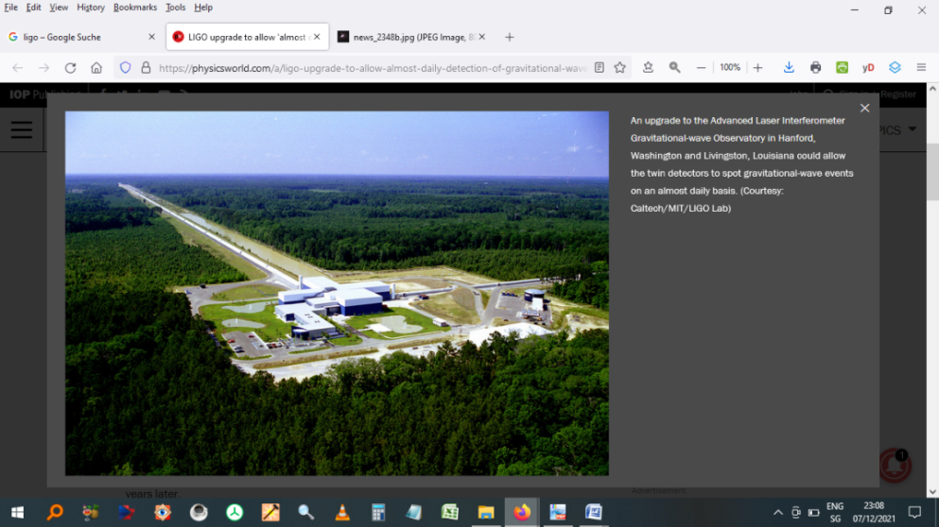

*Note.* Image source: <https://www.ligo.caltech.edu/image/ligo20150731c>

Since 2017, there has been a collaboration between the United States-based LIGO detectors and the Virgo gravitational wave detector near Pisa, Italy. With the additional data from this third detector, researchers can better localize the sources of the gravitational waves using **triangulation techniques**.

**Figure A10**

*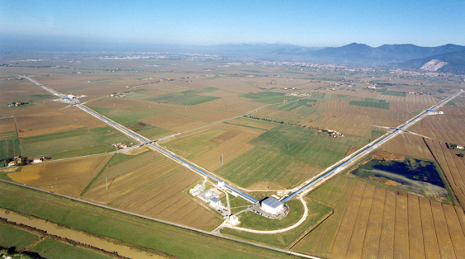Aerial view of the Virgo gravitational wave detector near Pisa, Italy*

*Note.* Image source: <https://www.aps.org/publications/apsnews/updates/ligo-virgo.cfm>

Since the first discovery, the LIGO-Virgo collaboration has made 90 confirmed detections of gravitational waves[33], mainly originating from the merger of two black holes. This direct observation of gravitational waves has thus opened a “new window” on the cosmos, since the information obtained from them about their sources is different from, and complementary to, that of electromagnetic waves. Gravitational-wave astronomy has thus become a new tool for observing the Universe.

# Appendix B – The Python Language

*If the implementation is hard to explain, it's a bad idea.*

*If the implementation is easy to explain, it* ***may[34]*** *be a good idea.*

Tim Peters, „PEP 20 - The Zen of Python”

In this section, in order to distinguish my comments and explanations from the Python code itself, I have highlighted all statements that can be a part of a Python program in blue.

## Importing Modules to the Code

To use the functionality present in external modules, the Python keyword command import is required in the code, together with the external module name. When the interpreter parses the import statement, it “pulls” the module to the current program. The grouping of imports should be in the following order:

1. Standard library imports.
2. Related third party imports.
3. Local application/library specific imports.

### Different Import types

**Full Module Import with alias**

import taichi as ti

**Direct Import (Selective Import)**

from pyautogui import size

**Multiple Import (Explicit Import)**

import (Thread,

Event,

Lock)

**Wildcard imports** (from <module> import *) should be avoided, as they make it unclear which names are present in the namespace.

## Comments

Comments start either with a hash or begin and end with three quote marks. They should be complete sentences, the first word being capitalized (unless it is an identifier that begins with a lower case letter). A comment can be written entirely on its own line, next to a statement of code, or as a multi-line comment block.

Examples

# This line is a comment.

a = 6.1 # Everything after the hash is a comment.

“”” This is a

multiple line block

of comment. “””

## Variable Naming

Variable names are case-sensitive.

### Multiple-word variable names

Variable names consisting of more than a single word can be difficult to read. There are several options for improving their readability:

* **Pascal Case**

Each word starts with a capital letter: MyVariableName

* **Camel(back) Case**

Each word, except the first, starts with a capital letter: myVariableName

* **Snake Case**

Each word is separated by an underscore character: my_variable_name

I use this third option in all code presented in this document.

### Dynamic Typing

Python is a **dynamically typed** language[35]: it doesn't “know” about its variable types until the code is run. Indeed, there is no command for declaring a variable! This implies that variables, parameters, and return values of a function can be any type and are set during the run of the program.

Python has the following data types built-in by default:

|  |  |
| --- | --- |
| Text Type | str |
| Numeric Types | int, float, complex |
| Sequence Types | list, tuple, range |
| Mapping Type | dict |
| Set Types | set, frozenset |
| Boolean Type | bool |
| Binary Types | bytes, bytearray, memoryview |
| None Type | NoneType |

Examples

**Python statement Data Type**

x = "Hello World" String (str)

x = 42 Integer (int)

x = 1.1 Floating Point (float)

Furthermore, the types of variables can **change while the program is running.** The (current) data type is obtained with the type() function:

print (type(x))

## Evaluation Order of an Expression

When Python evaluates an assignment, the source (right-hand side) is evaluated before the target (left-hand side), each side in left to right order. For any subscript in the target, the container is evaluated before the subscript.

## Data Collections (Aggregate Data Types)

There are four data types used to store **collections** of data (multiple items) “inside” a single variable (container):

* list
* tuple
* set (and frozenset)
* dictionary.

The differences between them have to do with whether they

* are **ordered** (and can therefore be indexed)
* allow **duplicate members** (multiple elements with identical contents)

are **mutable** (their values are changeable during execution).

**List**

Lists can hold items of different data types, including other lists. They are defined by enclosing the items in square brackets [], with each item separated by a comma.

Examples

Assignment

my_empty_list = [] # empty list

my_list = [1, "Hello", 3.4] # list with mixed data types

Access

my_list [0]

Output

1

Access

my_list [-1]

Output

3.4

**Tuple**

The contents of a tuple are immutable (unchangeable during execution): This immutability allows faster execution; iteration through a tuple is faster than for a list (which is mutable). Referencing is with an integer index (which may be negative). Parentheses are optional.

Examples

Assignment

this_tuple = 0, 0

that_tuple = "Monty", "Python’s", "Flying", "Circus"

the_other_tuple = ("apple", "banana", "cherry")

Access

that_tuple[1]

Output

Python’s

The various data types and the subset of them that are **aggregate** data types are listed in Tables **B1** & **B2**, respectively.

**Table B1**

*The Python Built-in Data Types*

|  |  |  |  |
| --- | --- | --- | --- |
| Data type | Name | Example | Comments |
| Text | str | a = "Norwegian Blue" | str() - constructs a string from a wide variety of data types, including strings, integer literals and float literals. |
| Numeric | int | x = 42 | int() - constructs an integer number from an integer literal, a float literal (by removing all decimals), or a string literal (providing the string represents a whole number). |
| float | y = 4.2 | Numeric literals containing a decimal point or an exponent sign yield floating point numbers, which are represented as 64-bit double-precision values in Python. The maximum value any such floating-point number can have is approx. 1.8 x 10308. Any number greater than this will be indicated by the string inf. |
| float() - constructs a floating point number from an integer literal, a float literal or a string literal (providing the string represents a float or an integer). |
| complex | z = 1j | Appending 'j' or 'J' to a numeric literal yields an imaginary number (a complex number with a zero real part) which you can add to an integer or float to get a complex number with real and imaginary parts. |
| complex() can be used to produce complex numbers.  Both the real and imaginary parts are a floating point number. z.real and z.imag allow the extraction of these from a complex number z. |
| Sequence | list | x = ["Cleese", "Palin", "Jones"] |  |
| tuple | x = ("Gilliam", "Idle", "Chapman") |  |
| range | x = range(6) |  |
| Mapping | dict | x = {"name" : "Eric", "age" : 81} |  |
| Set | set | x = {"Dead", "Parrot", "Sketch"} |  |
| frozenset | x = frozenset({"I’m", "a", "lumberjack"}) |  |
| Boolean | bool | x = True | Almost any value is evaluated to True if it has some sort of content. Any string is True, except empty strings. Any number is True, except 0. Any list, tuple, set, and dictionary are True, except empty ones. |
| Binary Types | bytes | x = b"Hello" |  |
| bytearray | x = bytearray(5) |  |
| memoryview | x = memoryview(bytes(5)) |  |

**Table B2**

*The Python Aggregate built-in Data Types*

|  |  |  |
| --- | --- | --- |
| **Data type** | **Name** | **Properties for collections of elements, where applicable** |
| Text Type | str |  |
| Numeric Types | int |
| float |
| complex |
| Sequence Types | list | ordered, duplicates allowed, mutable |
| tuple | ordered, duplicates allowed, immutable |
| range |  |
| Mapping Type | dict |  |
| Set Types | set | unordered, duplicates not allowed, mutable |
| frozenset | **unordered,** duplicates not allowed, immutable (hence the name!) |
| Boolean Type | bool |  |
| Binary Types | bytes |
| bytearray |
| memoryview |

## Constructors

For numeric types, the **constructors**

* int()
* float() and
* complex()

can be used to produce numbers of a specific type.

## Operators

Python divides operators into the following groups:

* Arithmetic operators
* Assignment operators
* Bitwise operators
* Comparison operators
* Identity operators
* Logical operators
* Membership operators

### Assignment Operators

|  |  |  |
| --- | --- | --- |
| **Operator** | **Example** | **Same As** |
| = | x = 5 | x = 5 |
| += | x += 3 | x = x + 3 |
| -= | x -= 3 | x = x - 3 |
| *= | x *= 3 | x = x * 3 |
| /= | x /= 3 | x = x / 3 |
| %= | x %= 3 | x = x % 3 |
| //= | x //= 3 | x = x // 3 |
| **= | x **= 3 | x = x ** 3 |
| &= | x &= 3 | x = x & 3 |
| |= | x |= 3 | x = x | 3 |
| ^= | x ^= 3 | x = x ^ 3 |
| >>= | x >>= 3 | x = x >> 3 |
| <<= | x <<= 3 | x = x << 3 |

### Arithmetic Operators

|  |  |  |
| --- | --- | --- |
| **Operator** | **Name** | **Example** |
| + | Addition | x + y |
| - | Subtraction | x - y |
| * | Multiplication | x * y |
| / | Division | x / y |
| % | Modulus | x % y |
| ** | Exponentiation | x ** y |
| // | Floor division | x // y |

### Bitwise Operators

|  |  |  |
| --- | --- | --- |
| **Operator** | **Name** | **Description** |
| & | AND | Sets each bit to 1 if both bits are 1 |
| | | OR | Sets each bit to 1 if one of two bits is 1 |
| ^ | XOR | Sets each bit to 1 if only one of two bits is 1 |
| ~ | NOT | Inverts all the bits |
| << | Zero fill left shift | Shift left by pushing zeros in from the right and let the leftmost bits fall off |
| >> | Signed right shift | Shift right by pushing copies of the leftmost bit in from the left, and let the rightmost bits fall off |

### Comparison Operators

|  |  |  |
| --- | --- | --- |
| **Operator** | **Name** | **Example** |
| == | Equal | x == y |
| != | Not equal | x != y |
| > | Greater than | x > y |
| < | Less than | x < y |
| >= | Greater than or equal to | x >= y |
| <= | Less than or equal to | x <= y |

### Logical Operators

|  |  |  |
| --- | --- | --- |
| **Operator** | **Description** | **Example** |
| and | Returns True if both statements are true | x < 5 and  x < 10 |
| or | Returns True if one of the statements is true | x < 5 or x < 4 |
| not | Reverse the result, returns False if the result is true | not(x < 5 and x < 10) |

### Identity Operators

|  |  |  |
| --- | --- | --- |
| **Operator** | **Description** | **Example** |
| is | Returns True if both variables are the same object | x is y |
| is not | Returns True if both variables are not the same object | x is not y |

### Membership Operations

|  |  |  |
| --- | --- | --- |
| **Operator** | **Description** | **Example** |
| in | Returns True if a sequence with the specified value is present in the object | x in y |
| not in | Returns True if a sequence with the specified value is not present in the object | x not in y |

Source: <https://www.w3schools.com/python/python_operators.asp>

## Functions

A function allows the definition of a reusable block of code that can be executed many times, which is essential to **modular programming**.

The Python language passes arguments neither by reference nor by value, but **by assignment**. It uses a mechanism known as **Call-by-Object**, or **Call by Object Reference** (less commonly termed **Call by Sharing**). This is equivalent to passing a **pointer** in other languages.

### Default argument passing

Sometimes the user cannot or does not wish to provide a value for one or more parameters that are taken by a function. For those arguments for which no value is passed during the function call, **default values** are used. These are provided in the parameters list, where the assignment operator ‘=’ is used for them.

Example

def sum(a=5, b=7): # function with default argument

""" This function will print the sum of two numbers

if the arguments are not supplied

it will add the default value """

print (a+b)

### The return statement

The Python style guide (called *PEP8*) is noncommittal towards whether the return statement should contain one (or more) variables vs. returning a value without assignment in the function.

Examples

def my_function (argument1, ...):

a = value_calculated_from_the_arguments

return a

def function2(argument1, ...):

return value_calculated_from_the_arguments

## Checking the Code

A bit of etymology...

**Lint** is the common name for visible accumulations of textile fibres that can detach from clothing. A modern tumble dryer uses something called a lint screen to collect these remnants. Thus, linting, used as a verb, is the “cleaning of tiny bits of fluff”. Python code requires such initial “linting”, in the figurative sense, to help the programmer find simple common errors in the source code (which is particularly important because of Python’s dynamic typing and the “missing” compilation step which would normally do most of this work). The **linter** thus provides warnings about errors in syntax and formatting, as well as the use of locally unspecified variables. It performs **static analysis** of source code and can be regarded as a simple **debugger**.

Examples

* **Pyflakes.** The Spyder IDE (integrated development environment)uses the simple parser called Pyflakes, available at <https://pypi.org/project/pyflakes/>

Pyflakes is faster than **Pylint** (primarily because the former only examines the syntax tree of each file individually). The cost/drawback is that Pyflakes is thus more limited in the types of things it can check.

* **Pylint**, whose name explicitly refers to its function, is available - although not used in this project - at <https://pypi.org/project/pylint/>

**Figure B1**

*Example of a linting option for the Spyder IDE (integrated development environment)*

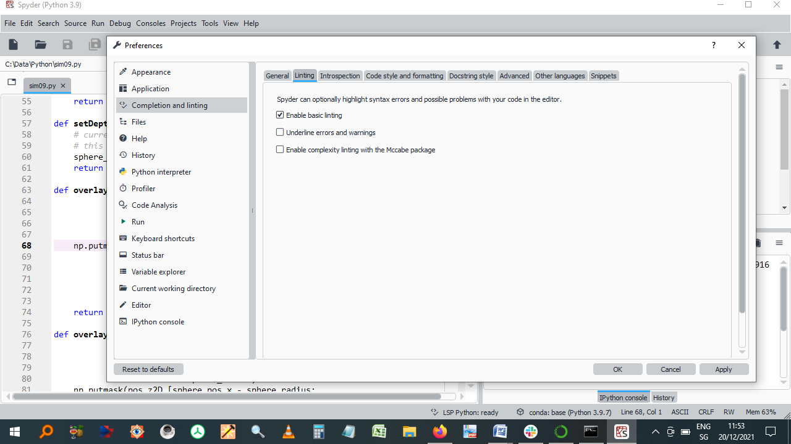

***Note.*** This can be found in: *Spyder -> Tools -> Preferences -> Completion and Linting*

**Figure B2**

*Another tool for linting!*



**Figure B3**

A tumble dryer



# Appendix C – The Tkinter GUI

## Brief code example and explanation

### Creation of a Frame (highlighted here, for emphasis, by the yellow box)

**Frame widgets** are used to group/organise other widgets on the screen. The Frame controls the positions of the individual widgets that fit inside it using a geometry manager. Tkinter has three such manager methods for organizing layout: **pack()**, **grid()** and **place()**. After some experimentation with all three, I decided to use the first of these, as it was, for me, the easiest and simplest.

In the example here, the **Frame** widget is instantiated with a black background (**bg="black"**), then attempted to be placed at the top of the main GUI window. However, because another frame has already been specified first, the new frame sits directly underneath it.

**Figure C1**

*Part of the GUI (Graphical User Interface)*

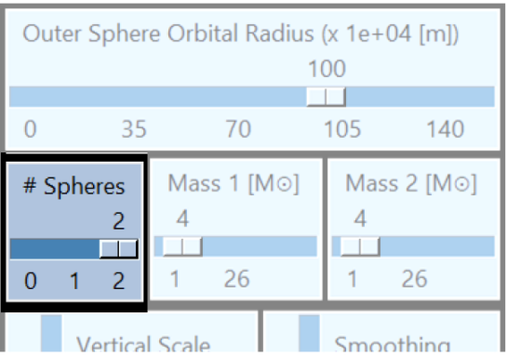

***Note.*** Author’s image

The **pack** method places the frame using (**side=TOP**) and makes it expand horizontally (**fill=X**) to take up the full width of the GUI window:

padx, pady = 2, 2

horiz_slider_arguments = {

"bg": "light steel blue",

"troughcolor": "steel blue",

"orient": "horizontal",

}

…

frame = Frame(root, bg="black")

frame.pack(side=TOP, fill=X, padx=padx, pady=pady) # Expand frame to full width but not height

The root variable is used as the parent window for all other widgets.

This frame will contain three widgets, placed in a row: all of them here are of the type **slider**.

The code provided shows only the first, left-hand-side one. This slider, labeled "# Spheres", is associated with a Tkinter variable called `tkinter_spheres_to_display`. The slider allows users to select a value from 0 to 2, with tick marks at intervals of 1. Some padding, defined by padx and pady is placed around each widget inside the frame, for aesthetic reasons:

slider_spheres_to_display = Scale(frame,

label="# Spheres",

variable=tkinter_spheres_to_display,

from_=0, to=2,

tickinterval=1,

**horiz_slider_arguments)

slider_spheres_to_display.pack(side=LEFT, padx=padx, pady=pady, fill=X)

slider_spheres_to_display.set(2)

## Colours with Tkinter

These are represented in one of two ways:

* As a string specifiying the proportion of red, green and blue, in hexadecimal digits. For example, "#fff" (white), "#000000" (black), "#000fff000" (green).
* Using defined standard colour names. Examples are: "white", "black", "red", "green", "blue", "cyan", "yellow", and "magenta".

I use only the latter.

Examples

"bg": "light steel blue": light steel blue background

"troughcolor": "steel blue": steel blue slider trough colour

### Colour options

|  |  |
| --- | --- |
| **Name** | **Function** |
| activebackground | Background for the widget when the widget is active. |
| activeforeground | Foreground for the widget when the widget is active. |
| background | Background for the widget. This can also be represented as bg. |
| disabledforeground | Foreground for the widget when the widget is disabled. |
| foreground | Foreground for the widget. This can also be represented as fg. |
| highlightbackground | Background of the highlight region when the widget has focus. |
| highlightcolor | Foreground of the highlight region when the widget has focus. |
| selectbackground | Background for the selected items of the widget. |
| selectforeground | Foreground for the selected items of the widget. |

An exhaustive list of Tkinter named colours is shown here.

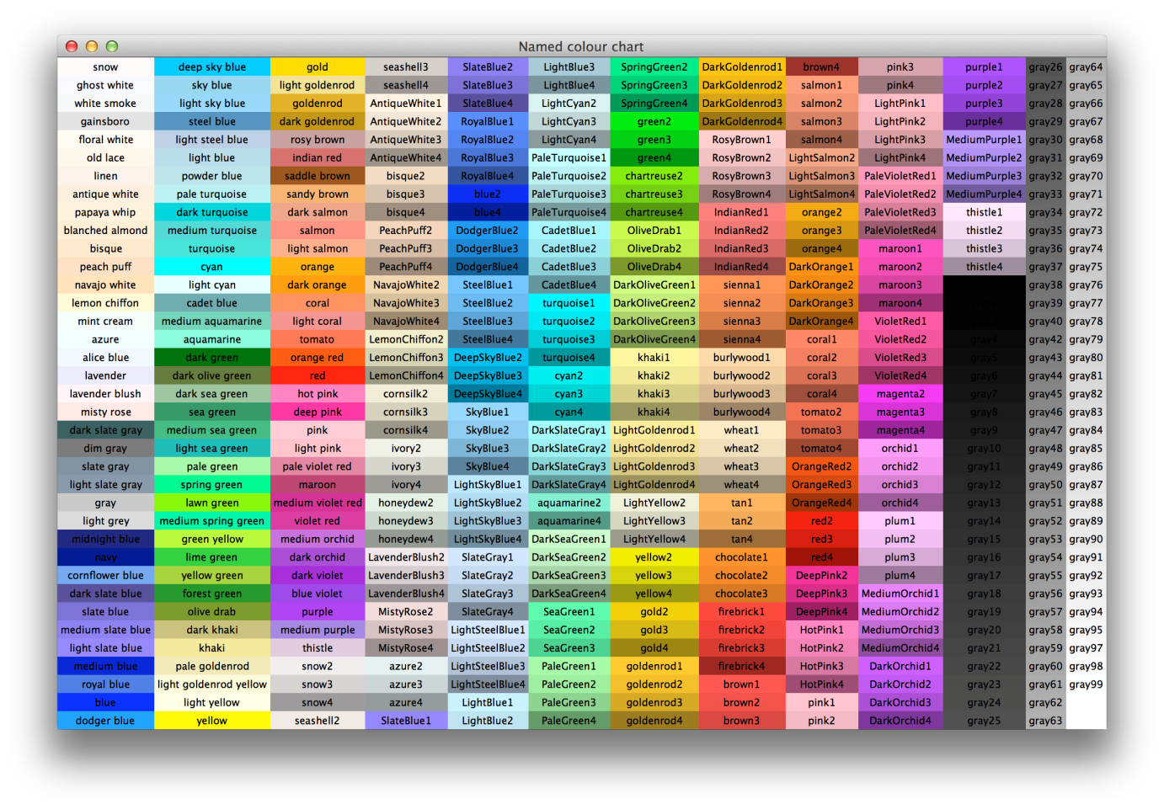

# Partial Glossary

These terms are those that are referred to, but not explicitly expanded upon, in the main body of the text. I include those that may be unfamiliar to some readers, terms, particularly from computer science. Some entries have been taken and modified from the following sources:

<https://en.wikipedia.org/wiki/Glossary_of_computer_science>

<https://www.computerhope.com/jargon.htm>

<https://www.ibm.com/ibm/history/documents/pdf/glossary.pdf>

The remaining entries are my own text.

**Application Programming Interface (API)**

A software interface that enables applications to communicate with each other. An API is the set of programming language constructs or statements that can be coded in an application program to obtain the specific functions and services provided by an underlying operating system.

**Argument**

A data value passed to a function. Arguments are assigned to the named local variables in a function body. There are two kinds of argument in a function call:

* **keyword** argument: an argument preceded by a name label (an identifier, e.g. *name=* )
* **positional** argument: an argument that is not preceded by an identifier and whose position in the call therefore matters (usually to be placed before all keyword arguments).

**Array Slicing**

Array slicing is an operation that extracts a subset of elements from an array and packages them as another array, possibly in a different dimensionality from the original.

**Callback**

A Python function that takes no arguments.

**Class**

In an object-oriented language, a construct that encapsulates a group of variables and methods.

**Code Comment**

An annotation or explanation in the source code of a program. Its purpose is to make the code easier to understand. Comments are ignored by interpreters and compilers.

**Core**

Synonym: **CPU core**

A core receives instructions, and performs calculations, or operations, to satisfy those instructions. A single CPU can have multiple cores inside it. Each core can perform operations independently of the others. The majority of consumer CPUs currently feature between about two and twelve cores.

**CUDA**

Originally: Compute Unified Device Architecture, acronym discontinued.

CUDA is an architecture for GPUs developed by NVIDIA, introduced in 2007. It improves the performance of those computing tasks which benefit from parallel processing. CUDA GPUs feature several thousand CUDA cores, integrated onto a single video card. Software must be written specifically for the architecture. Although the native programming language is C++, so-called wrappersare written for other languages.

**Decorator**

A decorator is a callable function (or, sometimes, a class) that accepts either a function or a class and returns a new one that “wraps” around the original one. A function or a class in Python is decorated with the @ symbol followed by the decorator name on the same line. The body of the function or class then starts on the following line.

**Duck Typing**

Duck Typing is a concept related to dynamic typing, where the type or the class of an object is less important than the method it defines. Using duck typing, types are not checked at all. Instead, there is a check for the presence of a given method or attribute. (The reason for the name: “If it looks like a duck, swims like a duck, and quacks like a duck, then it probably is a duck”.)

**Dynamic Typing**

The term means that a compiler or an interpreter assigns a type to all the variables at run-time, the types being decided based on their values.

**Function**

A reusable block of code designed to perform a specific task or computation. Functions take inputs, process them, and return an output.

**Garbage Collection**

The process of freeing memory when it is not used anymore. Garbage collection automates this process using a garbage collector to search for previously allocated memory that is no longer being used by a program. In some programming languages, this freeing of memory must be done manually. Python does it automatically and allows additional control via something called the *gc module*.

**Generator Function**

A function which returns a generator iterator. It looks like a normal function except that it contains **yield** expressions for producing a series of values usable in a for-loop or that can be retrieved one at a time, using the **next()** function. Each yield action temporarily suspends processing, remembering the location execution state (including local variables).

**Graphics Processing Unit (GPU)**

The GPU is an electronic circuit used to speed up the creation of both 2D and 3D images. GPUs can either be

* **integrated** (built into the computer's CPU or motherboard), or
* **dedicated**, as a separate piece of hardware known as a video card.

By having its own, separate, processor, the GPU allows the computer's CPU resources to be used for other tasks.

**Immutable Object**

In Python, an object with a fixed value which cannot be altered during program execution. Immutable objects include numbers, strings and tuples. (If the object is immutable when we update the variable, we actually point it to another object, and Python’s garbage collection will recycle the original object if it is no longer used.)

**Interpreted Language**

An interpreted computer language is a type of programming language in which most of the instructions are executed directly by an interpreter rather than being compiled into machine code beforehand. The interpreter processes the instructions on-the-fly.

**Iterator**

Synonym: **Iterable**

An iterable is any object that can return its members one at a time as a stream of data, by repeated calls.

Python has two commonly used types of iterables:

* Sequences (element access using integer indices)
* Generators

**Just-in-time** (**JIT**) **compilation**

Synonyms: **Dynamic translation**, **run-time compilation**.

This is a way of executing computer code that involves compilation during execution of a program (at run time) rather than as an independent step before execution.

**Namespace**

The place where a variable is stored. Namespaces support modularity by preventing naming conflicts and they aid readability and maintainability by making it clear which module implements a function.

**Object**

Member or instance of a particular class. It contains real values instead of variables.

**Object-oriented programming**

Synonyms: **OOP, OO programming.**

A programming language paradigm in which the code can be structured as reusable components, some of which may share properties or behaviours. Its basic “building blocks” are classes and objects.

**Passing by reference**

When passing by reference is used, the memory address of an argument is passed into the function. This means that the function can change the current value of the argument.

**Passing by value**

When passing by value is used, a copy of the argument's value is passed into the function. This means that the function cannot change the original value of the argument.

**PEP** (Python Enhancement Proposal)

A PEP is a design document providing information to the Python community, or describing a new feature for the Python language. PEPs are intended to be the primary mechanisms for proposing major new features, for collecting community input on an issue, and for documenting the design decisions that have gone, and continue to go, into Python.

**Pythonic**

An idea or piece of code which closely follows the most common idioms of the Python language, rather than implementing code using concepts common to other languages.

**Return Value**

The value(s) that a function returns when it completes.

**Scope**

Synonym: **Visibility**

The reference to an entity (in Python, any object) may not be possible from all places in the code. If this is the case, then in some parts of the program the name may refer to either a different entity, or to nothing at all. The region(s) of the code where a correct and error-free reference can be made to the object is called that object’s scope.

**Static Typing**

A **statically-typed** language is a language (such as Java, C, or C++) where variable types are known at compile time. Although Python is a **dynamically typed** language, it is possible to code so-called **type hints**, which make it possible to perform type checking of Python code. In contrast to genuinely statically-typed languages, however, type hinting does not cause Python to enforce the types given and can thus be regarded as code comments.

**System Bus**

Synonyms: **FSB** (front-side bus), **processor bus**, **memory bus**

Connects the CPU (chipset) with the main memory and cache.

**Type Hinting**

An indication, as part of the code, of the data type of a variable, in order to make the code more self-explanatory. This is usually done within the relevant function.

Python Example

def sum(num1**: int**, num2**: int**) **-> int:**

return num1 + num2

**Wrapper**

A wrapper describes an intermediate set of functions that allow one piece of software to be accessed directly by other software, without additional computation. For instance, compiled software written in the C++ programming language may offer a wrapper that allows it to be used directly by programs written in Python.

**Yield**

A keyword used to return from a function without destroying the states of its local variables. When the function is called, the execution starts from the last yield statement. Any function that contains a yield keyword is termed a **generator.**

**Zen of Python**

Listing of Python design principles and philosophies that are helpful in understanding and using the

language. The listing can be found by typing “import this” at the interactive prompt.

1. Four of the other common styles for citing scientific papers, not used here, are MLA Style (Modern Language Association), Chicago Style, IEEE Style and Harvard Style.
2. The technique for modelling a thin elastic sheet is also known as the **thin-shell material model** and is also used in the textile industry for the computer simulation of garments. The requirements for modelling an elastic sheet in my implementation are clearly different from textiles, however; for example, we do not need to simulate environmental factors such as viscosity and wind.
3. Spandex is a synthetic fabric prized for its elasticity. The term refers to polyether-polyurea copolymer fabrics that have been made with a variety of production processes. The terms *spandex, elastane* and *Lycra* are synonymous. The only one of these, slightly surprisingly, that is a brand name, is *Lycra*.
4. The Earth’s and the Sun’s masses are, to two significant figures, 6.0**·**1024 kg and 2.0**·**1030 kg, respectively.
5. Although this is hardly consoling for anyone falling to the ground from just a few metres!
6. <https://www.youtube.com/watch?v=cyW0LWEACfI>
7. Other notational schemes exist, but do not necessarily make life easier for the student, as Susskind emphasises at the beginning of his recorded video lectures on general relativity.
8. Before becoming a secondary school teacher, I used to work at some of the larger banks, both in London and in Zürich.
9. A high level language is a programming language that enables a fairly straightforward implementation of a sequence of ideas (algorithm) into computer code. High level languages allow the writing of programs which are almost independent of the particular type of computer used to run them. Examples, apart from Python, include Fortran and Pascal. In contrast, a low level language is “machine-oriented” because the code must be specified in terms of the capabilities and specifications of the processor. Examples include assembly language and machine code.
10. One idea at the time was to use Python for the front-end user interface and image dispay and the much faster Fortran language to deal with the more calculationally intensive aspects of the implementation. However, this became unnecessary once another solution had been found.
11. No other forces, including gravity!
12. Ironically for the title of this subsection, Newton and Hooke, who were contemporaries and knew each other, didn’t get along at all.
13. This *k* is not to be confused with the same symbol used for the slopes in the Runge-Kutta method, which will be discussed shortly.
14. Looping still takes place, but is relegated to optimized, pre-compiled C code which “lies beneath” the code seen by the programmer.
15. As, incidentally, can Matplotlib. Unfortunately, Matplotlib cannot access GPUs to increase its performance.
16. This is because it uses something called the **Visualization Toolkit (VTK)** for its graphics, which itself uses openGL.
17. A particularly nice feature of Mayavi is its sophisticated GUI which allows rotation of viewing field of view in both directions, as well as a zoom option.
18. *Tkinter* comes from *Tk interface*. It was written by Steen Lumholt and Guido van Rossum (once again!).
19. It is cross-platform, so the same code works on Windows, macOS, and Linux.
20. A widget is also a device placed in an aluminium container of beer to manage the characteristics of the beer's [head](https://en.wikipedia.org/wiki/Beer_head). The original widget was patented in Ireland by [Guinness](https://en.wikipedia.org/wiki/Guinness).
21. However, the different threads do not actually execute at the same time: they merely appear to do so.
22. Not to be confused with *tai chi,* theancient [Chinese martial art](https://en.wikipedia.org/wiki/Chinese_martial_arts) in which practitioners perform a series of deliberate, flowing motions while focusing on deep, slow breaths.
23. An equivalent formulation is

    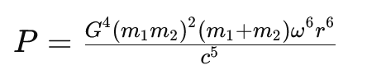
24. This spurious reﬂection, caused by inaccurate treatment of the artiﬁcial boundaries, is not caused by the finite precision of the simulation (unlike the discretization errors in general).
25. The 1919 expeditions (Dyson et al., 1920) are further discussed in Coles (2001) and Gilmore et al. (2020): The latter study reconfirms both the integrity and scientiﬁc objectivity of Eddington and the validity of the data obtained at that time. It is unfortunate that Stephen Hawking erroneously states in his 1988 bestseller *A Brief History of Time* (Hawking, 1988) that “ … later examination of the photographs taken on [the 1919 solar eclipse] expedition showed the errors were as great as the effect they were trying to measure. Their measurement had been sheer luck … ”. This statement is untrue.
26. Swedish astronomer Knut Lundmark appears to have been the first person to find observational evidence for the expansion, in 1924. Three years later, Belgian priest and cosmologist Georges Lemaître presented somewhat more exact observational evidence, correctly stating that the relationship between distance to galaxies and their recessional velocity is a linear one. Edwin Hubble confirmed their findings in 1929 and it is generally he who is credited with the observations confirming the Universe’s expansion. (Modified from Wikipedia.)
27. There is no recorded evidence that it was observed from other parts of the world, not even in Europe.
28. Its so-called **apparent magnitude** in the sky is 8.4. Since the astronomical magnitude scale is **reverse logarithmic** (the brighter an object is, the lower its magnitude number; a difference of 1.0 in magnitude corresponds to a brightness ratio of 2.512) and assuming that the limit of naked eye perception is (in best nighttime observing conditions) magnitude 6.0, the difference of 2.4 magnitudes works out as a brightness factor difference of around 2.5128.4 - 6 = 9.12. This means that the Crab nebula is nine times too faint to be seen with the unaided eye.
29. Provided that this acceleration is not perfectly spherically or cylindrically symmetric.
30. Several attempts were made, prior to 1915, of constructing such theories, notably by Heaviside, Poincaré and Nordstrom. However, none of these alternatives was as fully worked out as the version by Einstein.
31. Unfortunately there were no gravitational wave detectors on Earth in the year 1054!
32. Although their speed (the magnitude of their velocity) may not be changing, their direction of movement is. This is sufficient, for only one of these two properties need change for acceleration to be occurring.
33. Results of the third Gravitational-Wave Transient Catalog (GWTC-3) on November 7, 2021, including events released in prior observing runs.
34. My emphasis.
35. Other such languages include: JavaScript, PHP, Lisp and Ruby.